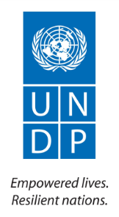

Contract number: 2012/284-007

**Project Title: Support to Confidence Building Measures Starting date:** 15 March 2012

**Report end date:** 28 February 2013

**Implementing agency:** UNDP Moldova

**Country:** Republic of Moldova

TABLE OF CONTENTS

[I. SUMMARY 4](#_Toc353278568)

[II. CONTEXT 6](#_Toc353278569)

[III. PROJECT BACKGROUND 7](#_Toc353278570)

[1. Business Development Component 8](#_Toc353278571)

[2. Infrastructure, community and social projects component 8](#_Toc353278572)

[3. Support to civil society component 9](#_Toc353278573)

[IV. SUMMARY OF IMPLEMENTATION PROGRESS 10](#_Toc353278574)

[1. Business Development component: 10](#_Toc353278575)

[2. Infrastructure, community and social projects component: 10](#_Toc353278576)

[3. Support to Civil Society component: 11](#_Toc353278577)

[V. STATUS OF IMPLEMENTATION PER SUB-PROJECT: 12](#_Toc353278578)

[5.1 Business Development component 12](#_Toc353278579)

[5.1.1. Creating a sustainable system of business education in Transnistria 12](#_Toc353278580)

[5.1.2. Provision of business support and development services in Moldova and its Transnistrian region 13](#_Toc353278581)

[5.1.3. Market Survey of the Microfinance sector in the Transnistrian region 16](#_Toc353278582)

[5.1.4. Development of Business Incubators 16](#_Toc353278583)

[5.2. Infrastructure, Community and Social Projects Component 17](#_Toc353278584)

[5.2.1. Community Infrastructure Rehabilitation 17](#_Toc353278585)

[Sub-Project 1: “Enhancing capacities of general education through the reconstruction of Cocieri village lyceum, Dubasari District” 18](#_Toc353278586)

[Sub-Project 2: “Enhancing capacities for pre-school education in Slobozia-Dusca village, Criuleni District”. 18](#_Toc353278587)

[Sub-Project 3: “Promoting the confidence building measures through Reconstruction of the House of Culture from Cosnita village, Dubasari District” 19](#_Toc353278588)

[Sub-Project 4: “Promoting a pro-environment water management in Hagimus village, Causeni district” 19](#_Toc353278589)

[Sub-Project 5: “Enhancing capacities of the public health services from Rezina through renovation of the Traumatology and Reanimation Department of the Rezina District Hospital”. 20](#_Toc353278590)

[Sub-Project 6: “Promoting a pro-environment sewerage management in Balabanesti village, Criuleni district” 20](#_Toc353278591)

[Sub-Project 7: “Enhancing capacities of general education through the reconstruction of Vadul-Rascov village’s lyceum, Soldanesti District” 21](#_Toc353278592)

[Sub-Project 8: “Promoting a pro-environment water management in Talmaza village, Stefan Voda District” 21](#_Toc353278593)

[Sub-Project 9: “Enhancing capacities for pre-school education in Molovata Noua village, Dubasari District”. 22](#_Toc353278594)

[Sub-Project 10: “Enhancing capacities for pre-school education in Pirita village, Dubasari District”. 22](#_Toc353278595)

[Sub-Project 11: “Promoting the confidence building measures through the reconstruction of the central road from Varnita village” 23](#_Toc353278597)

[Sub-Project 12: “Promoting the confidence building measures through the construction square community trade in the village of Firladeni” 23](#_Toc353278598)

[Sub-Project 13: “Promoting the confidence building measures through the reconstruction of the street lighting system in the village of Climautii de Jos, District of Soldanesti” 24](#_Toc353278599)

[Sub-Project 14: “Promoting the confidence building measures through the reconstruction of the street lighting system in the village of Ustia, District of Dubasari” 24](#_Toc353278600)

[Sub-Project 15: “Building opportunities for pro-health education in Criuleni town” 25](#_Toc353278601)

[Sub-Project 16: “Building opportunities for pro-health education in Chircaiesti village, Causeni district” 25](#_Toc353278602)

[Sub-Project 17: “Enhancing capacities of general education through the reconstruction of Puhaceni village’s lyceum, Anenii Noi District” 26](#_Toc353278603)

[Sub-Project 18: “Promoting a pro-environment water management in Cioburciu village, Stefan Voda District” 26](#_Toc353278604)

[Sub-Project 19: “Promoting a pro-environment sewerage management in Holercani village, Dubasari district” 26](#_Toc353278605)

[Sub-Project 20: “Enhancing capacities of the public health services from Criuleni through renovation of the Paediatric Department of the Criuleni District Hospital”. 27](#_Toc353278606)

[Sub-Project 21: “Promoting the confidence building measures by renovating streets in Vasilievca village, Cocieri Mayoralty, Dubasari District” 27](#_Toc353278607)

[Sub-Project 22: “Enhancing capacities of the public social protection services from Dubasari District through creation of the Social Home for Elderly People from Oxentea village”. 28](#_Toc353278608)

[Sub-Project 23: “Enhancing capacities for pre-school education in Tibuleuca village, Dubasari district”. 28](#_Toc353278609)

[Sub-Project 24: “Enhancing capacities for pre-school education in the city of Tiraspol through reconstruction of the kindergarten nr.44 for visually impaired children”. 29](#_Toc353278610)

[Sub-Project 25: “Enhancing capacities for pre-school education in Ternovca village, Slobozia district”. 29](#_Toc353278611)

[Sub-Project 26: “Building opportunities for pro-health education in Grigoriopol town” 30](#_Toc353278612)

[Sub-Project 27: “Enhancing capacities of general education through the reconstruction of Butor village school, Grigoriopol district” 30](#_Toc353278613)

[Sub-Project 28: “Building opportunities for pro-health education in Parcani village, Slobozia district” 31](#_Toc353278614)

[Sub-Project 29: “Enhance Women's Economic Empowerment in communities on both banks of Nistru River” 31](#_Toc353278615)

[5.2.2 Integration of health specialist care - Support to Strengthening Perinatal Care and Immunizations in Transnistrian region 32](#_Toc353278616)

[5.2.3 Environmental projects 32](#_Toc353278617)

[5.3. CIVIL SOCIETY COMPONENT 33](#_Toc353278618)

[5.3.1. Civil Society Sub-projects 33](#_Toc353278619)

[Sub-project 1: „Modern media across Nistru” 34](#_Toc353278620)

[Sub-project 2: “Enhancing media capacity in Moldova and the Transnistrian region” 35](#_Toc353278621)

[Sub-project 3: „ Road safety and casualty reduction” 36](#_Toc353278622)

[Sub-project 4: „ Social interaction in a changing society: building trust and stability” 38](#_Toc353278623)

[Sub-project 5: „ Transnistria Conflict Resolution Task Force” 38](#_Toc353278624)

[Sub-project 6: „ European Integration and Conflict Settlement in Moldova-Transnistria 39](#_Toc353278625)

[Sub-project 7: „Building capacity for empowerment of vulnerable women and men, as well as promoting human-centred development across the Nistru 40](#_Toc353278626)

[Sub-project 8: „ The democratization of the Transnistrian region through human rights protection” 40](#_Toc353278627)

[Sub-project 9: “Half empty or half full” 41](#_Toc353278628)

[Sub-project 10: „ Promoting foster families services in Transnistrian Region” 42](#_Toc353278629)

[Sub-project 11: „ Support to disabled people from Transnistria and Moldova” 43](#_Toc353278630)

[Sub-project 12: „ Monitoring the human impact on the Nistru River” 43](#_Toc353278631)

[5.3.2. Dialogues programme/Civil Society Support to Working Groups 44](#_Toc353278632)

[VI. PROJECT RISKS, ISSUES AND ACTIONS TAKEN 44](#_Toc353278633)

[VII. MEDIA COVERAGE 45](#_Toc353278634)

# I. SUMMARY[[1]](#footnote-1)

|  |  |
| --- | --- |
| Total duration of the action | 36 months |
| Objectives of the action | The overall objective of the programme is to facilitate the settlement of the Transnistrian issue through ensuring economic and social development of local communities and increasing confidence between both banks of the Nistru River by involving local authorities, civil society organisations, business community and other stakeholders.  Project specific objectives:   * To enhance economic development in the Transnistria region and the security zone and contribute to economic rapprochement between the two banks of the Nistru River by promoting cross-river exchanges and expanding the range of catalytic business support services; * To empower local communities and actors from both sides to participate in collaborative projects addressing pressing development needs and ensure the delivery of essential public services; * To address common environmental development concerns by creating opportunities and platforms for joint collaboration from both banks; * To foster civil society development by enhancing the capacity of NGOs to generate activities which promote cross-river collaboration and addressing key development needs. |
| Partner(s) | The Government of Moldova, the Bureau for Reintegration, relevant line ministries, regional and municipal authorities, community-based organizations, international, national and local NGOs active in the Transnistrian region and the security zone. |
| Target group(s) | * Economic actors including SMEs, Chambers of Commerce, business associations, etc. from both banks of Nistru River; * Communities and community-based organizations in the Transnistria region and the security zone; * Health specialists on both banks as well as beneficiaries of health institutions on both banks; * Environmental actors, including specialists and affected communities; * Civil society organizations in the Republic of Moldova including the Transnistria region; |
| Final beneficiaries | * Citizens in the Republic of Moldova including the Transnistrian region |
| Estimated results | * Catalytic development of the SME sector in the Transnistrian region and security zone; at least 200 SMEs benefiting from better business support services and improved management skills; at least 50 cross-river exchanges promoted * Communities empowered to participate in addressing local development needs with least 40 small social infrastructure projects implemented; at least 40 cross-river exchanges supported. * Capacity of national, sub-national and local institutions in the environmental sector enhanced to address environmental priorities. * Capacity of civil society organisations strengthened to address pressing social and community needs; at least 30 cross-river NGO partnerships supported * Increased contacts between actors on both banks in the social, cultural, economic and environmental sectors * Increased trust and confidence between citizens on both sides of the Nistru River |
| Main activities | The above will be tackled through the following **project components**:  **1. Business Development** – Projects which promote the common interests of business actors from both banks in the context of EU integration will be implemented. The SME sector will be supported through continued business education activities; establishment of a business incubator and other facilities and formats to provide support services to entrepreneurs; and a road map for micro-financing will be defined.  **2. Community Development** – Projects will be implemented which enable and empower citizens on both banks to jointly participate in tackling community development needs, particularly the rehabilitation of social institutions and basic infrastructure as well as improve access to and quality of mother and child health care, including perinatal care and immunization in the region. Small grants will be provided to community-based organizations to encourage community mobilization.  **Joint environmental projects** will also be implemented, as part of this component. This will provide an opportunity for the development of joint solutions in addressing common environmental concerns, building on successful cooperation between authorities, civil society organizations, specialists and communities.  **3. Support to Civil Society** – Grants will be provided to NGOs to enhance NGO capacity for generating activities which reduce mistrust and increase confidence; to harness NGO expertise for producing practical improvements in areas relevant to the population; and to encourage cross-river NGO partnerships. |

# II. CONTEXT

After gaining independence in 1991 Moldova has witnessed political instability and the territorial disintegration of the country, whereby the region of Transnistria seceded from Moldova in 1992 but is not recognised by any member of the international community. The problems associated with Transnistria represent an obstacle to stability and development, and a 20-year long spell of unresolved conflict has widened the divide between societies and elites on the two banks of the Nistru River. The dearth of official and unofficial channels for cooperation and policy formulation on salient issues prevents key stakeholders from engaging in realistic examination of policy options and development scenarios, which reduces the space for an informed discussion on what could be done to address burning social and economic needs.

In an effort to promote community and business-level rapprochement between the banks, the Transnistrian case needed to be approached from a development angle, as both sides are facing similar developmental problems which could be more efficiently addressed through joint efforts and programs. The Government of Moldova proposed confidence-building measures (CBM) in order to contribute to conflict settlement, country reintegration and improvement of relations between the people. The focus was on economy, trade, transport, healthcare, education and other areas. The international community welcomed this move, as it could help to overcome the distrust between Tiraspol and Chisinau.

The approach pioneered by the Moldovan Government has been taken up through EU’s confidence building projects, implemented by UNDP Moldova. The programme proposed for implementation was based on a thorough analysis of the development priorities of both banks. The first part of this effort came about as a EUR 1.7 million CBM package in 2009-2011. In line with its philosophy, the programme moved away from political issues – where discussions could quickly lead to deadlocks - and focused on areas that have direct repercussions on the needs of the population, such as healthcare, the social sector and environment. A variety of organizations and institutions from Transnistria were involved in the implementation process, which ensured buy-in from local communities, built up local capacity and reduced the isolation of the region.

The implementation of the first component, while very difficult conceptually and practically because of unfavourable operating environment, has provided valuable lessons and expertise, “socialized” both banks into the non-political nature and scope of projects and smoothed the way for the second phase, “Building confidence between Chisinau and Tiraspol”, which ran from January 2010 to December 2011 with an overall budget of €2 million. In line with the strategic thinking of engaging Transnistria and stepping up successful CBM work, the current, third phase of the programme “Support to Confidence Building Measures” (April 2012 – March 2015), with the total budget of €10.6 million (€9.5 provided by the EU and €1.1 by UNDP) focuses on the following major areas: business development; community infrastructure health care, environment and support to civil society. All sub-projects are designed to enhance confidence by addressing specific development needs of the two banks and establishing bridges and links between communities, NGOs, local authorities, specialists and experts working in different sectors.

Following a change in power structures in Transnistria in late 2011, when the long-time leader Igor Smirnov lost to the young politician Evgheny Shevchuk, relationship between Moldova and the Transnistrian region have seen some progress as the parties have increasingly focused on socio-economic problems that they could resolve together (such as economic cooperation, trade, social projects). Progress has been achieved in some areas, including the resumption of railway traffic but has been limited in other areas, which defy ready-make solutions, and this work has increasingly become deadlocked again. This makes the EU’s CBM work for both sides ever more relevant, but also increases the conceptual and practical challenges of coordinating project work and implementing projects on the ground.

This holds good of the program overall and of each of its five components separately. In terms of business development, the region is going through an economic crisis and downturn. The Transnistrian region – with its export-driven economy - has borne the full brunt of plunging market demand. The crisis aggravated the structural shortcomings of Transnistria’s economy, which depends heavily on a limited number of export industries and has little capacity to produce for the domestic market. The five-year trend witnessed a decline in industrial output. It picked up somewhat in 2011, to 850 million USD in 2011, a 27.3% increase from 2010, while the GDP per capita reached 1,592 US dollars.  In 2011 the average wage in Transnistria has grown up to 270 US dollars, compared with 245 USD in 2008. The average wage of public-sector workers is 174 USD.

This precarious situation drives the authorities’ focus on developing the SME sector to generate employment, alleviate the impact of the economic crisis by absorbing the outflow of the workforce laid off from public-run companies, offset the impact of the declining industrial output on the region’s economy, as well as prop up the demand on the domestic market. Small business trends demonstrate that the SME sector has significant growth capacity, but the sector remained underdeveloped and weak, compared with right-bank Moldova and the potential for exchanges and development rollover between the banks is big. This provides major opportunities for the SME development and exchanges component of the program.

In terms of infrastructural projects, the demand on both sides is enormous, as infrastructure assets are wearing down and few. Joint community and infrastructure projects on both banks targeting key institutions are therefore in high demand. As for the health sector, previously conducted assessment and analysis have shown that reforms of the perinatal care system in the Transnistria region were long overdue. First phase of the project has partially addressed them; bringing Moldova’s specialists to the left bank to launch the initial stage of reforms and create a 3-level perinatal system to match the one that exists in rest of the country. The scope of the intervention was by necessity limited but has proven highly successful both in terms of technical implementation and in terms of confidence building. Efforts in view of advancing the reform by including the perinatal health care from Rybnitsa in the broader network will be made, as well as tackling urgent needs in the field of immunization and paediatric care.

# III. PROJECT BACKGROUND

**“The overall objective of the project** **is to increase confidence between Chisinau and Tiraspol by involving municipalities, civil society organizations and other stakeholders in economic and social confidence building projects**. The project addresses the needs of vulnerable communities, with a specific focus on Transnistrian region of Moldova, including the security zone. The project supports the establishment of cross-river partnerships, promotes economic cooperation and contributes towards confidence building among the actors and the population at large.

The programme aims at enhancing socio-economic development of the Transnistria region, bringing the sides closer as well as promoting and strengthening cooperation between Chisinau and Tiraspol in such fields as health, social support, environment protection, education, SME development etc., involving in this process specialists, entrepreneurs, civil society leaders as well as the general population on the two banks of the Nistru river. Creating the connectedness between the two sides and benefits for the people of Moldova, including its Transnistria region, is at the core of the programme.”[[2]](#footnote-2)

In order to closely reflect these priorities, development interventions for the third phase of the programme have been identified in close consultations with the key stakeholders (Bureau for Reintegration, the EU Delegation, line ministries, development agencies, donor organizations active in the region, Regional Development Agencies, Transnistria’s central and local authorities, other institutions from both sides). The new interventions were as well based on a thorough review of previous two phases’ achievements and lessons learnt[[3]](#footnote-3). Key principles for programming included ownership, transparency, continuity, gradualism, flexibility, responsiveness and a conflict-sensitive, win-win approach.

As the project unfolded, the team has carefully managed relations and partnerships built in Moldova and its Transnistrian region to ensure smooth implementation of all areas of the program. Close coordination, knowledge sharing and joint work was ensured between different UN agencies to share knowledge and expertise. Furthermore, efforts were made to mainstream gender across all components, aiming to make positive and transformative contribution to the achievement of gender equality and women’s empowerment.

During the first year, the programme has fully and firmly established itself on the ground and has created solid prerequisites for successful work during the second year. The project has managed to launch all activities, even though some have taken more time than expected and therefore have been slower (as in the case of environmental projects), they are rapidly picking up at the beginning of the second year, reaching their full potential. In most areas, such as business development and civil society, the projects’ performance has exceeded expectations and ensured that the rate of programmatic delivery has usually been above the plan.

## Business Development Component

There is a significant interest on both sides in developing economic activities and improving the livelihoods of the people. The assumption is that economic cooperation could bring sizeable benefits and create linkages between the sides, as well as bridge the divide between the increasingly estranged economic sectors. Business support programs benefit the population and teach the sides to resolve common problems together, because the nature of both sides’ economic problems is similar, as are the risks and structural shortcomings both economies face.

The business development component of the programme aims at addressing the key constraints to SME development and seeks to address the areas where the available resources can make the most difference, boosting the competitiveness of the SME sector and fostering cross-border business linkages and cooperation.

The key structural impediments to SME development in the region, according to the study conducted in 2010, include a host of issues ranging from high taxes, intrusive checks by controlling agencies and lack of business education to political and economic instability. From among those, the following four constraints have been selected: lack of business training programs and qualified cadre; lack of business support infrastructure, including business incubators; lack of capital, investments, and affordable loans; and lack of joint business development programs and projects for both sides.

The first constraint has been addressed by setting up a network of business schools across Transnistria to develop the local pool of entrepreneurial skills and provide business training to beginner entrepreneurs, managers of existing SMEs and CEOs, as well as train local business trainers to meet the growing local demand for business education. In view of addressing the issue of lack of business support infrastructure, the establishment of a business incubator is considered, based on previously conducted assessment, while a study on Transnistria’s micro-finance environment is looking into the opportunity of setting up micro financing facilities and tackling lack of access to finance. Finally, lack of joint business development opportunities and programs was addressed through joint business support and advisory services for both sides, including study visits to identify potential business opportunities, as well as consultancy and business support services for targeted beneficiaries on both banks of the Nistru River. All of these projects are interrelated and provide valuable systematic support for SME development.

This component of the project envisaged careful steps towards establishing more links between the business communities on both banks. At the same time, the political situation in the region and the high degree of suspicion towards CBM programs made it an issue which had to be carefully managed in order to circumvent risks of closure of projects in the field of business development. The project included an increased amount of joint activities for entrepreneurs on both banks such as joint participation at seminars, joint visits to EU etc. contributing to increased interaction and cooperation between economic agents.

## Infrastructure, community and social projects component

Building on pioneering UNDP experience working with communities in the Transnistria region, projects under this domain are designed to address pressing community needs while providing an opportunity for people-to-people contacts across the banks. These projects have proven to be a sustainable confidence building initiative. Projects focus on the rehabilitation of key social institutions, such as educational and health facilities, and improvements to critical physical infrastructure, such as water supply and sewage networks, addressing joint environmental concerns and improving access to and quality of mother and child health care, including perinatal care and immunization. Each project promotes people-to-people contacts and cross-river exchanges.

The problems that communities on both banks are faced with are similar and they are jointly involved in order to better resolve them. The infrastructure projects were identified through a thorough participatory process which involved relevant stakeholders: initially within socio-economic development action plans of the communities, followed by two calls for proposals, during which over 135 project proposals have been received from both banks.

The activities derived from the approaches, experience and best practices of UNDP interventions at community level in Moldova, where communities were assisted in social mobilisation, formation and support of community organisation mechanisms, provision of technical and financial support to community-led development projects. Capacities among community members were developed for sustainable local development processes such as identifying and prioritizing community development needs and developing strategies for addressing identified problems.

Environmental and health projects (in the areas of perinatal care and immunization) will start in the coming months. The demand for these projects is high and potential for CBM work in these areas is very strong.

## Support to civil society component

Civil society projects facilitate people-to-people links and joint cooperation by building or enhancing the capacity of NGOs to develop, deliver and participate in projects which enhance confidence between the two banks. Grants support NGOs whose project proposals promote cooperation between key actors from the two sides, establish or reinforce cross-river NGO partnerships, involve the transfer of knowledge and expertise across banks and/or address pressing social and community needs.

Projects also generate activities which reduce mistrust and increase confidence. Platforms are created to link specialists from both banks who share common interests. Expanding on programming from previous phases, the project encourages cross-river NGO-to-NGO partnerships. Harnessing NGO expertise to produce practical improvements in areas relevant to the population, cross-river NGO-to-community links are promoted. The programme has increased support to a broader range of NGOs, including in the sports and culture sectors.

Joint projects have been successfully implemented in non-political areas such as human rights, joint research, legal support, democratic values, environment, social protection, community mobilization, HIV/AIDS, children and the elderly. As a result of a fully competitive selection process, twelve proposals were selected and implemented in these areas by the time of the reporting. This work has ensured successful co-operation between CSOs on both banks and local authorities in tackling community issues.

In order to continue the support for initiatives and actions that foster development of civil society in the Transnistrian region, the Project initiated the second call for proposals, where priority was given to initiatives establishing cross-river partnerships between two or more organizations; proposals that foster the citizen’s involvement in solving pressing community problems, as well as innovative projects that represent models that can be replicated or applied at a larger scale. 117 project proposals have been received in media, arts and culture, research and analysis, democratic values, community participation; fight against poverty and social exclusion; human rights, environmental protection, arts and culture. They undergo a thorough process of review and assessment and further to the approval by the Selection Committee and Programme Board will be implemented in the following year.

# IV. SUMMARY OF IMPLEMENTATION PROGRESS

**Programme specific objectives:**

* To enhance economic development in the Transnistria region and the security zone and contribute to economic rapprochement between the two banks of the Nistru River by promoting cross-river exchanges and expanding the range of catalytic business support services;
* To empower local communities and actors from both sides to participate in collaborative projects which address pressing development needs and ensure the delivery of essential public services;
* To address common environmental development concerns by creating opportunities and platforms for joint collaboration from both banks;
* To foster civil society development by enhancing the capacity of NGOs to generate activities which promote cross-river collaboration and addressing key development needs.

A snapshot of achievements under these objectives includes:

## Business Development component:

A host of business development activities impacted on the capacity of more than **300 entrepreneurs** on both banks of Nistru River.

* The new phase of the ***Business School Project*** has been launched. It provides trainings to beginner entrepreneurs, mid-level managers, CEOs and business trainers; implemented by a consortium of TN/MD companies selected through an open tender. The project is in high demand and is aimed to make TN more business-friendly, giving people the tools to rely more on themselves;
* ***Provision of Business Support and Development Services***:

Two study visits for entrepreneurs from agro-industrial complex, construction companies, energy-efficiency from both banks of Nistru were organized: one to Poland (October 2012), one to Austria (November 2012);

* **Consultancy Services**: Business Consulting unit has been set in Rybnitsa; 10 consultants have been hired and trained; 95 SMEs were contacted, 36 requests have been processed; 26 Transnistrian companies participated at the Round Table “Regional Cooperation” in the Moldovan-Russian economic forum; two seminars organized in Rybnitsa: “Free Trade Agreement between Moldova and EU” and “Quality Management Systems at Enterprises”.
* A ***survey into Transnistria’s micro-finance environment*** is being carried out by a consortium of Moldovan/Transnistrian research companies, selected through an open tender. It is nearing completion and is expected to produce a blueprint for establishing a micro-finance facility for SMEs or extend an existing microfinance arrangement from Moldova into TN.
* The business incubator project is planned to extend the network of business incubators from the right bank to the left bank.

## Infrastructure, community and social projects component:

* Two calls for proposals have been launched.
* Over 200 proposals have been received from both banks and evaluated by a representative Selection Committee.
* Additional to the in-office evaluation, site visits to over 72 communities were performed. Based on detailed evaluation and as a result of a fully competitive process run by a representative Selection Committee, which included the key stakeholders, 28 project proposals were approved for funding. Of these, 22 are on the right bank and 6 are on the left bank, activities being implemented in the following areas: rehabilitation of schools, water supply and sewage systems, kindergartens and medical institutions, roads, waste management, streets/light systems, cultural systems.
* 18 projects are carried out through Grant agreements with the communities, the rest are implemented through UNDP’s direct procurement process;
* 28 projects will have been finalized by end-2013.
* The geographical areas will span the entire security zone on both sides of the river – projects have been selected to ensure a wide geographical distribution.

Environmental projects are in the course of implementation and joint approach is being applied here as well, as experts, civil society and professionals in this area from both sides work together to identify areas where the project’s resources could be best used to address common environmental concerns. A brief needs assessment will identify several projects that will have an impact on both sides and they will be translated into specific projects. The activities in the field of heath, which are in high demand on both sides and where the potential for CBM work is high, will be run by UN’s specialized agencies and will start in the coming months in the areas of perinatal health and immunization.

## Support to Civil Society component:

* Two calls for proposals have been launched, inviting projects from civil society organizations from both banks under two streams of grants: grants for established organizations (up to 100,000 USD) and small grants (25,000 USD)
* Areas: media (joint work and training programs for journalists and TV reporters from both banks); arts & culture (joint artistic and cultural activities including music, painting, dance); research and analysis (joint work of researchers, sociologists, political scientists, civil society leaders to create joint platforms for research and monitoring of public perceptions); democratic values (training and research programs for civil society leaders, opinion makers, experts and public activists from both banks in democratic principles, institutions, values and organizations); community participation (fight against poverty and social exclusion; prevention of child violence; awareness-raising projects for socially vulnerable, HIV/AIDS); human rights (economic, social and cultural rights, healthcare, children’s, consumers’, patients’ rights, people with special needs), community needs and access to social services; environmental protection and management of natural resources
* Very strong interest was generated in civil society programs, over 100 proposals received in the first round and 117 in the second. A strong focus was on creating NGO partnerships from both banks. The key criteria for evaluating the proposals included confidence building component, originality and feasibility.
* A representative selection committee has thoroughly evaluated the proposals, selecting 12 joint projects, 2 of which have been completed and 10 are on-going.
* Selection process is on-going under the second call for proposals, projects will be recommended for Programme Board approval on March 27, 2013.

**Informal civil society support to CBM Working Groups:** This project will establish a platform for representatives of WGs, decision-makers, civil society representatives, experts and professionals from relevant sectors to draft development projects. Focus will be made on the fields of Economy / Trade and Social Policy /Humanitarian Aid. The platform will help the sides identify key pressing issues which can be realistically addressed.

# V. STATUS OF IMPLEMENTATION PER SUB-PROJECT:

## 5.1 Business Development component

### 5.1.1. Creating a sustainable system of business education in Transnistria

**Implemented by: Chamber of Commerce and Industry of Transnistria in partnership with SGS (Societe Generale de Surveillance) Moldova**

**Direct beneficiaries:**

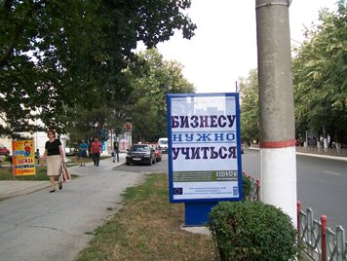beginner entrepreneurs, managers of existing SMEs and mid-level managers, CEO’s and managers of large companies, beginner and experienced entrepreneurs of the agro-industrial sector, civil servants, business-school specialists and business trainers, population at large

*Light box in Tiraspol advertising Business School*

**Budget:** 455,500 EUR

**Timeframe:** July 2012 – June 2014

**Overall goals of the project:**

* Support the network of 3 business schools in Transnistria to address gaps in local training capacity and to insure the sustainability of the business education system.
* Conduct business training programs for six target segments (beginner entrepreneurs, managers of existing SMEs and mid-level managers, CEO’s and managers of large companies, beginner and experienced entrepreneurs of the agro-industrial sector, civil servants, business-school specialists and business trainers) to boost SME’s competitiveness and start up rates, to enhance the contribution of the SME and agricultural sector in the economic growth and development
* Train the business school trainers to create sustainable local training capacity and expertise, to conduct research and ensure experience sharing
* Conduct communication campaign to promote business education and training and encourage the population to launch their own businesses

**Status: on-going, 50% completed**

* 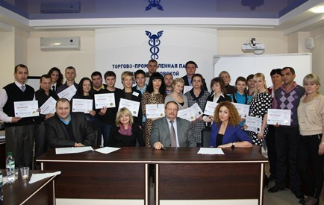16 Business School trainers have improved their skills contributing to further institutional capacity building and longer term school’ sustainability, as a result of three 3days modules focusing on the specific needs of the Business school trainers in view of systematizing their knowledge and skills in preparing and conducting trainings.
* Two introductory seminars “Free business education – new beginning for entrepreneurs” were conducted to select the students for two courses (1 in Tiraspol and 1 in Bendery). 40 students graduated the courses in December, presenting viable Business Plans to launch their own businesses. Similar course in Bendery has been launched and is on-going.

*Graduation Ceremony of beginner entrepreneurs in Tiraspol*

* The seminars for the middle and top-level managers were tailored to the daily needs of businesses, such as: “Innovations that work”, “The merger or division of the company: decision factors”, “Levels of Managerial Art”, “Effective sales of goods and services over the phone”, “E-commerce, internet marketing, affiliate program to promote a business in the internet”, “Accounting and taxation for small business”, “Exhibition – management tool of modern business”. 138 managers benefitted from the seminars.
* Four training programs for professionals and entrepreneurs engaged in agro-industrial complex were conducted to increase the input of the agro business in economy: “Fruit-growing”, “Open field vegetable production”, “Field, grain and industrial crops” and “Intensive technologies of pig and cattle production”. Study visits to the local successful agricultural enterprises were organized. 104 beneficiaries participated in the activities.
* A study visit to the Czech Republic of the CEOs from the following sectors: machine manufacturing, light industry (textile and shoes manufacturing), food processing (wine and brandy production, sturgeon and caviar production, diary) took place. Business to Business meetings, group visits to the Czech enterprises, as well as individual meetings were organized to share experience, to establish business cooperation and to promote Moldovan companies.
* 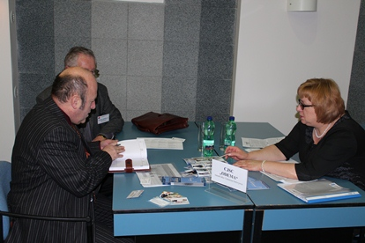A wide scale communication campaign has been conducted on local radio, TV and print media, via outdoor advertisement (billboards, light boxes, distribution of posters) and advertisement in social networks in Tiraspol, Bender and Rybnitsa. Advertising campaign was developed to attract active participants to the project who benefitted from free courses and seminars. The project has generated intense interest in Transnistria, with the number of applicants far exceeding the number of available slots. The Business School web site [www.bstiraspol.org](http://www.bstiraspol.org) was updated to promote the Project, to provide relevant information on the activities to be held within the project and to facilitate application process of the potential beneficiaries.

*B2B meetings, CEOs study visit to Prague*

Relevant links:

<http://www.bstiraspol.org/index.php?option=com_content&view=article&id=183&Itemid=212> <http://tiraspol.ru/news/?action=show&id=1722> <http://www.bstiraspol.org/index.php?option=com_content&view=article&id=182&Itemid=211> <http://www.bstiraspol.org/index.php?option=com_content&view=article&id=164:-q-q&catid=23&Itemid=7>; <http://tiraspol.ru/news/?action=show&id=1699> <http://tiraspol.ru/news/?action=show&id=1712> <http://www.bstiraspol.org/index.php?option=com_content&view=article&id=184&Itemid=208> <http://tiraspol.ru/news/?action=show&id=1713> <http://www.bstiraspol.org/index.php?option=com_content&view=article&id=180&Itemid=209> <http://tiraspol.ru/news/?action=show&id=1700>

### 5.1.2. Provision of business support and development services in Moldova and its Transnistrian region

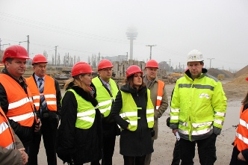***a)* “Organization of study visits”**

*Sight visit, study visit to Austria*

**Implemented by: Chamber of Commerce and Industry of Moldova in partnership with “Inter Econom Service” (CCI branch in Rybnitsa)**

**Direct beneficiaries:** business associations andentrepreneurs from both banks of Nistru River from the following sectors: sustainable construction, organic agriculture, rural tourism, agro-production, food processing, alternative bio energy resources.

**Project budget:** 106,300 EUR

**Project period:** July 2012 – April 2013

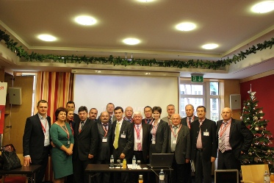**Overall goals of the project:** organization of three study visits to Poland, Austria and Germany with focus on identifying new business opportunities, facilitating the development of sustainable partnerships between the beneficiaries and business partners in Moldova, Poland, Austria and Germany. Participants are exposed to the best practices in their respective business areas and jointly participate at trade exhibitions in Europe, meet with European regional chambers of trade and commerce as well as business associations.

**Status: on-going, nearing completion**

Two study visits have been organised: to Poland and Austria. A mix of tools, designed not only to expose the participants to a complete range of events, but also to guide them to get involved in events, gasp ideas, skills and practices, making them benefit from relevant opportunities, were applied: business seminars, business conferences, meetings and round-tables, B2B meetings and Match-Making events, sector-focused field visits.

*Moldo-Austrian forum, study visit to Austria*

Induction seminars were organized before each trip to ensure full understanding of the objectives, structure and content of the study visits and enable participants to identify issues of particular interest.

Follow-up meetings, as well as feed-back questionnaires, proved the visits to be efficient: 52 possible future collaborations were negotiated; partnership agreements between the companies from the both banks were initiated; overall 43 entrepreneurs benefitted from these two visits.

Preparations for the study visit to Germany are on-going. The induction seminar will be organised before the visit in March, 2013.

Vast public awareness campaign about the study visits was insured. Press releases were published on the following web-pages: [www.chamber.md](http://www.chamber.md), [www.eco.md](http://www.eco.md), [www.yam.md](http://www.yam.md), [www.communicate.md](http://www.communicate.md), [www.moldpress.md](http://www.moldpress.md), [www.allmoldova.com](http://www.allmoldova.com), [www.ziarelive.ro](http://www.ziarelive.ro), [www.civic.md](http://www.civic.md), [www.cdm.md](http://www.cdm.md), [www.publika.md](http://www.publika.md), [www.stiri-ultima-ora.ro](http://www.stiri-ultima-ora.ro), [www.pressactors.com](http://www.pressactors.com), <http://yam.md/ro/story/1104740>; [www.interlic.md](http://www.interlic.md) <http://chamber.md/ro/nout%C4%83%C8%9Bi/262-la-viena-a-avut-loc-un-forum-de-afaceri-moldo-austriac>; <http://chamber.md/ro/nout%C4%83%C8%9Bi/256-businessmeni-de-pe-ambele-maluri-ale-nistrului-particip%C4%83-la-o-vizit%C4%83-de-studiu-%C3%AEn-austria>; <http://chamber.md/ro/nout%C4%83%C8%9Bi/255-%C3%AEntreprinz%C4%83tori-de-pe-ambele-maluri-ale-nistrului-vor-prelua-experien%C8%9Ba-austriac%C4%83>; <http://eco.md/index.php?option=com_content&view=article&id=7468:businessmeni-de-pe-ambele-maluri-ale-nistrului-particip-la-o-vizit-de-studiu-in-austria&catid=101:companii&Itemid=472> ; <http://www.comunicate.md/index.php?task=articles&action=view&article_id=6244> <http://moldpres.md/News.aspx?NewsType=eco> ;

<http://www.allmoldova.com/ro/moldova-news/1249069113.html>;

<http://www.civic.md/stiri/stiri-ong/19002-businessmeni-de-pe-ambele-maluri-ale-nistrului-particip-la-o-vizit-de-studiu-in-austria.html>;

<http://www.publika.md/20-de-oameni-de-afaceri-de-pe-ambele-maluri-ale-raului-nistru-participa-la-o-vizita-de-studiu-in-austria_1141141.html> ;

<http://stiri-ultima-ora.ro/2012/11/27/businessmeni-de-pe-ambele-maluri-ale-nistrului-participa-la-o-vizita-de-studiu-in-austria/> ;

<http://www.pressactors.com/moldova/search?q=vizita+austria> ;

<http://www.interlic.md/2012-11-26/businessmeni-de-pe-ambele-maluri-ale-nistrului-participa-la-o-vizita-de-studiu-in-austria-27393.html> ;

<http://www.ziarelive.ro/stiri/20-de-oameni-de-afaceri-de-pe-ambele-maluri-ale-raului-nistru-participa-la-o-vizita-de-studiu-in-austria.html> <http://cdm.md/?l=ro&a=7&i=89725>

***b).* “Provision of** **business consulting services**”

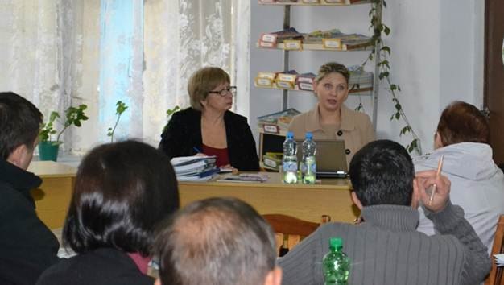**Implemented by: Chamber of Commerce and Industry of Moldova in partnership with “Inter Econom Service” (CCI branch in Rybnitsa)**

*Seminar in Rybnitsa on DCFTA*

**Project budget:** 33,400 EUR

**Project period:** September 2012 – July 2013

**Direct beneficiaries:** entrepreneurs from both banks of Nistru River

**Overall goals of the project:** Provision of joint consulting services to facilitate business links between Moldova and Transnistrian region, in the areas of export/import operations, trade between the two banks, EU quality systems, trade certificates, legislation, technical regulations, framework and policy documents and other business and trade related areas. The business consulting services will help to eliminate information gaps and provide a range of quality services strengthening the links between businesses from both banks and promoting their trade with each other and international partners.

**Status: on-going, nearing completion**

* The Business Consulting Unit was set in Rybnitsa on the basis of the branch of the Chamber of Commerce and Industry of RM “Intereconomservice”. Necessary office equipment was purchased. 10 consultants were selected to provide consultancy services within the framework of the Business Consultancy Unit. According to the field of their expertise, these consultants received a five-day induction training conducted by the relevant departments within the CCI of Moldova to be able to provide relevant services and to more effectively address the needs of the Transnistrian companies. The awareness campaign to inform about the Business Consulting Unit, availability of consultants, training programs and seminars was launched.
* 95 managers of SME from the Transnistrian region were contacted and visited by the consultants in order to be informed about the Business Consulting Unit, and by means of the questionnaires to assess the needs of the SMEs in terms of consultancy services. So far, 36 requests from SMEs to provide consultancy services upon different issues have been successfully settled.
* 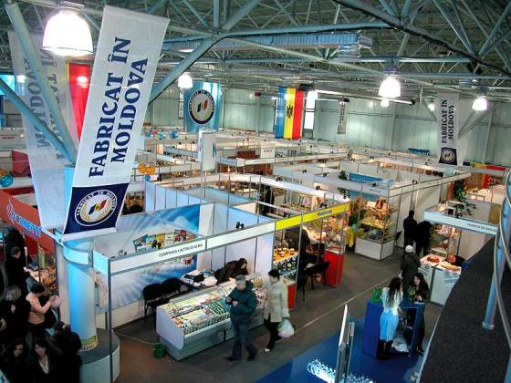Within the framework of the project CCI Moldova supported 26 Transnistrian companies to participateat the round table “Regional Cooperation” within the Moldovan-Russian economic forum to support the capacity development of Transnistrian companies to gain access to foreign markets and attract investors. Four companies from Transnistria were financially and logistically supported to exhibit their products at the exhibition “Made in Moldova” (30 January - 2 February), while another 26 had the possibility to visit the exhibition.
* As a separate activity Business Consulting Unit organized a number of seminars for the Transnistrian companies on current important issues: “The free trade agreement between EU and Moldova”, “The necessity of implementing quality management systems at enterprises”, “Customs legislation of Republic of Moldova and Transnistrian Region”. 78 entrepreneurs attended the seminars.

*4 TN companies participated at “Made in Moldova” exhibition*

Relevant links: <http://new.chamber.md/index.php?option=com_content&view=article&id=991%3Ala-chiinu-va-avea-loc-forumul-economic-moldo-rus&catid=74%3Anouti&Itemid=167&lang=ro>

<http://new.chamber.md/index.php?option=com_content&view=article&id=994%3Aforumul-economic-moldo-rus-a-reunit-peste-200-de-participani&catid=74%3Anouti&Itemid=167&lang=ro>

<http://new.chamber.md/index.php?option=com_content&view=article&id=952%3Aintreprinztori-din-stanga-nistrului-au-fost-informai-despre-avantajele-regimurilor-comerciale-ale-moldovei&catid=76%3Anouti-din-filiale&Itemid=240&lang=ro>

### 5.1.3. **Market Survey of the Microfinance sector in the Transnistrian region**

**Implemented by: NGO "Alternative Internationale de Dezvoltare” with Research Center “New Age”**

**Project budget:** 37,400 EUR

**Project period:** July 2012 – January 2013

**Direct beneficiaries:** entrepreneurs, owners of small and medium enterprises

**Overall goals of the project:** to conduct an in-depth survey of Transnistria’s micro-finance environment, to study the financing options available to SMEs, and draft a blueprint for establishing a micro-finance facility for SMEs engaged in joint business initiatives, or, if feasible, extending an existing microfinance arrangement from Moldova into its Transnistrian region.

**Status: on-going, nearing completion**

The contractor analysed Transnistria's microfinance sector, reviewing operational rules, regulatory framework, conducting stakeholders’ interviews, specifying key variables that determine demand for micro-finance lending. The experts defined characteristics of the microfinance sector in the Transnistrian region estimating the number of potential microfinance clients, total market coverage, analysing existing institutional models and existing supply of microfinance services on both banks of the Nistru River. Specific attention was paid to existing microfinance facilities in Moldova and the possibility of their extension into the Transnistrian region, their applicability in the Transnistrian region was thoroughly studied. The feasibility of launching and running of a microfinance facility in Transnistria, based on a thorough analysis of the environment in the Transnistrian region, a comparative regional assessment, as well as the findings of the research, was examined.

The final report will be presented in April.

### 5.1.4. Development of Business Incubators

The design of the project concept on establishment of two Business Incubators in the Transnistrian region (one in Tiraspol and one in Rybnitsa) is being finalized and coordinated with the relevant decision-makers. The basis for creation of these two entities was provided by the feasibility study undertaken in the previous phase of the programme in 2010, which identified the lack of business support infrastructure as another key constraint hindering **business development in the Transnistria region.** The establishment of business incubators, with the capacity to host and provide in-house advisory services to individual SMEs, **will address this gap. The business schools may serve as feeders for the business incubators, supporting entrepreneurs who have completed coursework and would like to refine their skills and develop their businesses further.**

These two incubators will become an extension of the network of the business incubators of the Republic of Moldova to the Transnistrian region. They will be established in close partnership with Organization for Small and Medium Business Development (ODIMM), which has created a network of incubators in Moldova, and other relevant stakeholders. ODIMM’s experts, along with international experts who supported ODIMM in establishing a network of business incubators in Moldova, will be closely involved in conceptualizing and operationalizing the project at every stage. The selection of resident companies and administration of the business incubators will also be run in close partnership with ODIMM and other stakeholders.

The business incubators will focus on the development of local good practice examples. This objective should underlie all business incubators designs: physical infrastructure size, the informational infrastructure, the methodology of SMEs assisting etc. The specific objectives of the business incubators: supporting the enterprises development, diversifying the local economic activity, developing entrepreneurial culture, developing business consultancy sector, developing the networking with peers in the incubator and with external networks will also be met. There are risks that the authorities in the Transnistrian region may not approve the implementation of the project.

\*\*\*

## 5.2. Infrastructure, Community and Social Projects Component

## 5.2.1. Community Infrastructure Rehabilitation

Community-driven infrastructure rehabilitation projects in Transnistria and the security zone are addressing pressing community needs and ensure the delivery of essential public services while providing an opportunity for people-to-people contacts across the banks. These projects are also relevant and aligned to the objectives of the Strategy for the Development of the Security Zone, adopted by the Government of Moldova and will promote confidence building between the two banks of Nistru River; contribute to raising the attractiveness of the right bank Moldova for the population living on the left bank; intensify people-to-people contacts and exchanges across the river and reducing barriers for the free movement of people, goods and services in the Security Zone on both banks of Nistru River.

At the first Programme Board Meeting on 11th of April, 2012, “**Principles and Selection Criteria for the Community Development Component**” have been approved. Based on them two rounds of the call for proposals for communities located in the Security zone under Moldovan jurisdiction was launched on 19th April and 14th December 2012. Communities from the Transnistrian region, as outlined in the above mentioned document, have been addressed separately through a parallel participatory process, considering specificities of the region.

The rules for projects proposals submission, evaluation and implementation had been set out in the guidelines for applicants’ document. These documents had been posted on the [www.undp.md](http://www.undp.md) web site, as well as shared directly to district and community level local authorities. The programme announcement had been spread among the target localities, information sessions being conducted in each district. Two main considerations were highlighted: **Thematic area of work**, which included - rehabilitation of key social institutions, such as education, social protection and health facilities, and improvements to critical physical infrastructure, such as water supply, sewage networks and waste management and **Budget** - in order to ensure a tangible impact, the program will provide support to medium-sized infrastructural projects which will require a minimum budget of 50,000 USD, but not exceed 150,000 USD (for the first call) and 130,000 USD (for the second).

As a result of these two competitions, only from the Security Zone under Chisinau jurisdiction, 158 proposals were received (90 in the first call and 68 in the second). A through screening process was conducted, including administrative compliance review, evaluation of compliance to the eligibility criteria based on the Call for Proposals requirements, and in-depth assessment of the feasibility, including through field visits to document the situation on the ground. While proposals from the second call are still under review, as a result of the first one 22 project proposals were selected by the Evaluation Committee and approved for funding by the Programme Board.

Along with the competition organised for the communities situated in the Security Zone on the right bank, the process for selecting potential projects from Transnistrian Region was carried out. In this regard, site visits to 30 communities were performed and 45 potential infrastructural projects were investigated. Six proposals out of 45 were selected and approved to be funded. Therefore, 28 proposals are under implementation, and 12 more are to be still selected (further to finalization of the evaluation process).

**Number of Sub-Projects:** 28

**Total budget committed for sub-projects:** 2,640,000 EUR

**Communities’ contribution:** 220,000 EUR

**Number of direct beneficiaries:** 82,000 persons

### C:\DOCUMENTS\UNDP\SCBM\Work Plans Reports\UE reports\2012\Foto + budjet partea dreapta1\Cocieri(liceul)-75 935,20 euro\IMG_2009.jpgSub-Project 1: “Enhancing capacities of general education through the reconstruction of Cocieri village lyceum, Dubasari District”

**Implemented by:** Cocieri administration, local implementation committee

**Direct beneficiaries:** over 500 children from Cocieri, Corjova, Roghi, Vasilievca, Molovata Noua villages, local community and authorities

**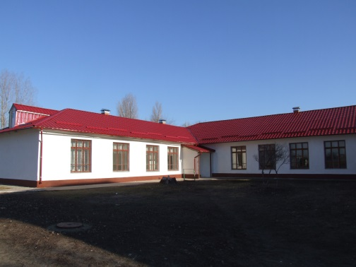**

**Budget:** 75,935 EUR

*Cocieri lyceum, before*

**Additional local contribution:** 2,062 EUR

**Timeframe:** October 2012 – March 2013

**Overall goals of the project:** Reconstruction of the roof of Cocieri village lyceum, Dubasari district.

**Status:** **95% of works are completed**

The project team has helped to establish the local implementation committee. All technical estimates have been carried out; a construction company has been selected through a public tender to run the works. Construction works are in the final stage. The rehabilitation of the premises expected to be completed in April 2013.

*Cocieri lyceum, works ongoing*

### C:\DOCUMENTS\UNDP\SCBM\Work Plans Reports\UE reports\2012\Foto + budjet partea dreapta1\Slobozia Dusca(gradinita)-98 156,42 euro\IMG_2220.jpgSub-Project 2: “Enhancing capacities for pre-school education in Slobozia-Dusca village, Criuleni District”.

**Implemented by:** Slobozia-Dusca administration, local implementation committee

**Direct beneficiaries:** over 210 children and their parents from Slobozia-Dusca village, local community, adjacent communities, local authorities

*Kindergarten in Slobozia-Dusca, before*

**Budget:** 98,156 EUR

**Additional local contribution:** 10, 500 EUR

**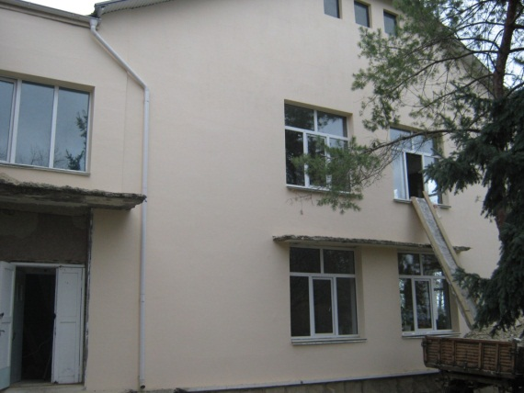**

*Kindergarten in Slobozia-Dusca, works ongoing*

**Timeframe:** November 2012 – March 2013

**Overall goals of the project:** Capital repair of block B and the Festivity Hall of the kindergarten from Slobozia-Dusca village. The kindergarten hosts 127 children from different social groups, but additional 70 children would have to be hosted after the reconstruction.

**Status: 85% of works are completed**

The project team has helped to establish the local implementation committee, negotiated and signed the Grant Agreement with the local community. All technical estimates have been carried out; a construction company has been selected through a public tender to run the works. Construction works are in the final stage. The rehabilitation of the premises expected to be completed in April 2013.

### Sub-Project 3: “Promoting the confidence building measures through Reconstruction of the House of Culture from Cosnita village, Dubasari District”

**Implemented by:** Dubasari district administration, local implementation committee

**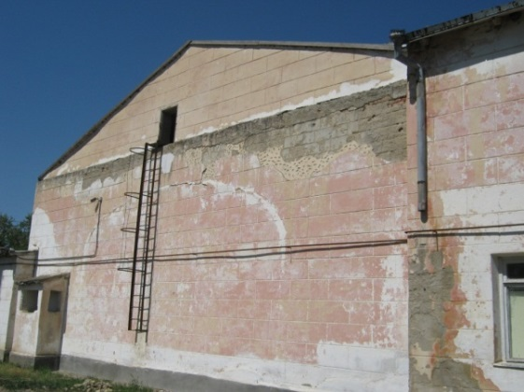Direct beneficiaries:** over 6200 people from Cosnita and villages from Dubasari district and nearby villages in the security zone, local community

**Budget:** 97,095 EUR

**Additional local contribution:** 27, 500 EUR

**Timeframe:** October 2012 – April 2013

**Overall goals of the project:** Capital reconstruction of the Dubasari district House of Culture: replacement of roof, doors, windows, floors, internal and external works etc.

*House of Culture from Cosnita village, before*

**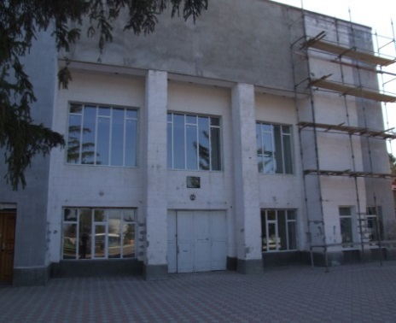Status: on-going, to be completed in April 2013**

The project team has helped to establish the local implementation committee, negotiated and signed the Grant Agreement with the Dubasari district administration. All technical estimates have been carried out; a construction company has been selected through a public tender to run the works. The reconstruction of the roof, façade and floor were finished - 60% of the planned works.

*House of Culture from Cosnita village, works ongoing*

### D:\UNDP\SCBM\Work Plans Reports\UE reports\2012\Foto + budjet partea dreapta2\Cioburciu(sonda+apeduct)-109 221,75 euro\IMG_2376.jpgSub-Project 4: “Promoting a pro-environment water management in Hagimus village, Causeni district”

*Old water tower*

**Implemented by:** Hagimuslocaladministration, local implementation committee

**Direct beneficiaries:** over 2,000people from local community, local authorities

**Budget:** 102,687 EUR

**Additional local contribution:** 22,500 EUR

**Timeframe:** November 2012 – March 2013

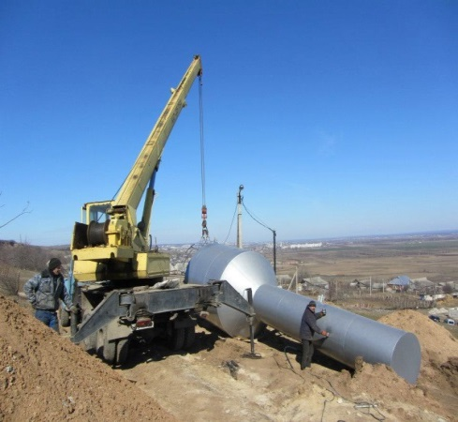**Overall goals of the project:** Reconstruction of the water system for the south part of the village and provide water to 60% of households and social institutions. This project involves a close collaboration with the Bender town water supply company due to its proximity, fact that will contribute to the confidence building.

*Reconstruction of the water system ongoing*

**Status: 70% of works are completed**

The project team has helped to establish the local implementation committee, negotiated and signed the Grant Agreement with the local community. All technical estimates have been carried out; a construction company has been selected through a public tender to run the works. The rehabilitation of the premises is to be completed in April 2013.

### D:\UNDP\SCBM\Work Plans Reports\UE reports\2012\Foto + budjet partea dreapta2\Rezina(spital raional)-83 673,38 euro\IMG_1990.jpgSub-Project 5: “Enhancing capacities of the public health services from Rezina through renovation of the Traumatology and Reanimation Department of the Rezina District Hospital”.

**Implemented by:** Rezina District administration, local implementation committee

**Direct beneficiaries:** 2000 people from Rezina District and Ribnita, adjacent communities from TN region, local authorities

**Budget:** 83,673 EUR

**Additional local contribution:** 13,125 EUR

**Timeframe:** December 2012 – April 2013

**Overall goals of the project:**

* Capital reconstruction of Traumatology and Reanimation Departments.

*Traumatology department before the works started*

* Contribute to experience exchange between Rezina and Rybnitsa health institutions as a strong confidence building element.

***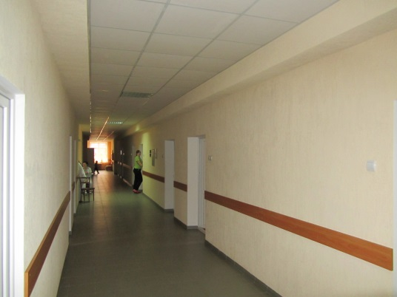***

**Status: on-going, to be completed in April 2013**

The project team has helped to establish the local implementation committee, negotiated and signed the Grant Agreement with the local community. All technical estimates has been carried out, a construction company has been selected through a public tender to run the works. At the moment the reconstruction of the floor, some internal works, replacement of doors and windows, replacement of electrical system, replacement of water supply and sewerage system were finished. 75% of works are completed.

*Traumatology department, works ongoing*

### C:\DOCUMENTS\UNDP\SCBM\Work Plans Reports\UE reports\2012\Foto + budjet partea dreapta1\Balabanesti(canalizarea+statie de pomparea)-\IMG_2437.jpgSub-Project 6: “Promoting a pro-environment sewerage management in Balabanesti village, Criuleni district”

*Balabanesti village, before the works started*

**Implemented by:** Balabanestilocaladministration, local implementation committee

**Direct beneficiaries:** over 3,600 people from Balabanesti village, adjacent communities, local authorities

**Budget:** 66,141 EUR

**Additional local contribution:** 9,350 EUR

**Timeframe:** November 2012 – March 2013

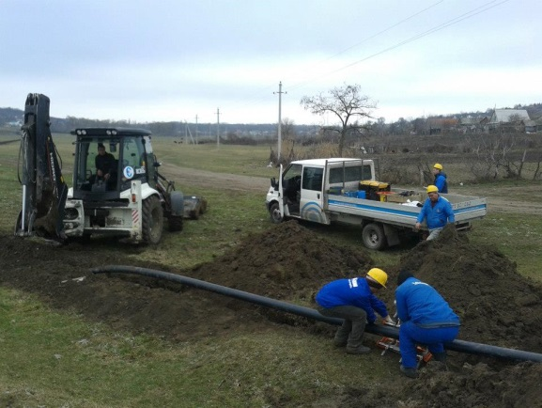

*Reconstruction of sewerage system ongoing*

**Overall goals of the project:** Reconstruction of the sewerage system and concession to existing treatment plant. The existing wastewater treatment plant should be connected to several public institutions to avoid damages on the environment.

**Status: on-going, 30% completed**

The project team has helped to establish the local implementation committee, negotiated and signed the Grant Agreement with the local community. All technical estimates has been carried out, a construction company has been selected through a public tender to run the works. Until now, over 1,5 km of pipes were replaced. The rehabilitation of the sewerage system is expected to be completed in April 2013.

### C:\DOCUMENTS\UNDP\SCBM\Work Plans Reports\UE reports\2012\Foto + budjet partea dreapta1\Vadul Rascov(liceul)-84 685,12 euro\IMG_2293.jpgSub-Project 7: “Enhancing capacities of general education through the reconstruction of Vadul-Rascov village’s lyceum, Soldanesti District”

**Implemented by:** Vadul-Rascov local administration, local implementation committee

**Direct beneficiaries:** over 350 students from Vadul-Rascov and four nearby villages in the security zone, local community

**Budget:** 84,685 EUR

**Additional local contribution:** 5,000 EUR

**Timeframe:** December 2012 – May 2013

*Lyceum Vadul-Rascov, before*

**Overall goals of the project:** Partial reconstruction of the Vadul-Rascov lyceum: replacement of roof, doors and windows, internal and external works etc. In addition to this, the UNDP “Energy and Biomass” project is going to install a heating boiler within this lyceum.

**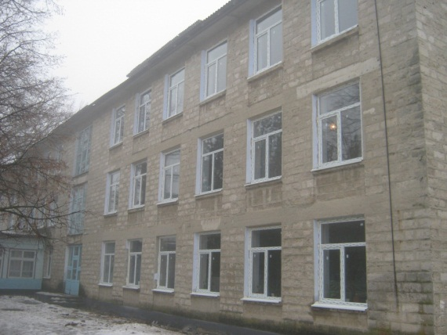**

**Status: on-going, to be completed in May of 2012**

The project team has helped to establish the local implementation committee, negotiated and signed the Grant Agreement with the Vadul-Rascov local administration. All technical estimates have been carried out, a construction company has been selected through a public tender to run the works. The replacement of windows and doors was finished, partial reconstruction of roof and some internal works were carried out. Works are on-going and the project is at 35% delivery.

*Lyceum Vadul-Rascov, works ongoing*

### Sub-Project 8: “Promoting a pro-environment water management in Talmaza village, Stefan Voda District”

**Implemented by:** Talmaza local administration, local implementation committee

**Direct beneficiaries:** over 7,200 people from Talmaza village, local authorities

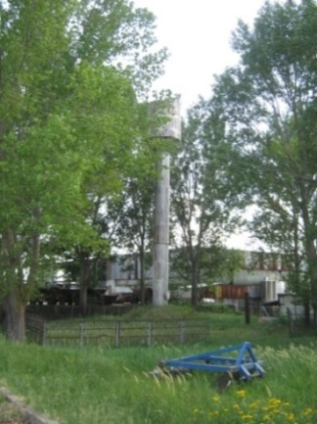**Budget:** 107,226 EUR

**Additional local contribution:** 18,000 EUR

**Timeframe:** November 2012 – April 2013

**Overall goals:** Reconstruction of the water system in the village, including one artesian well and provide water to 30% of households and social institutions.

**Status: on-going, to be completed in April 2013**

The project team has helped to establish the local implementation committee, negotiated and signed the Grant Agreement with the local community. All technical estimates has been carried out, a construction company has been selected through a public tender to run the works. At the moment 1 km of pipes were replaced. Works are on-going and the project is at 35% delivery.

### Sub-Project 9: “Enhancing capacities for pre-school education in Molovata Noua village, Dubasari District”.

**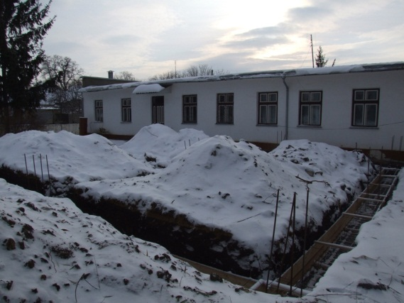**

*Molovata Noua kindergarten, before*

**Implemented by:** Molovata Noua administration, local implementation committee

**Direct beneficiaries:** over 150 children and their parents from Molovata and Roghi villages, local community, local authorities

**Budget:** 93,962 EUR

**Additional local contribution:** 16,875 EUR

**Timeframe:** Decembrie 2012 – June 2013

**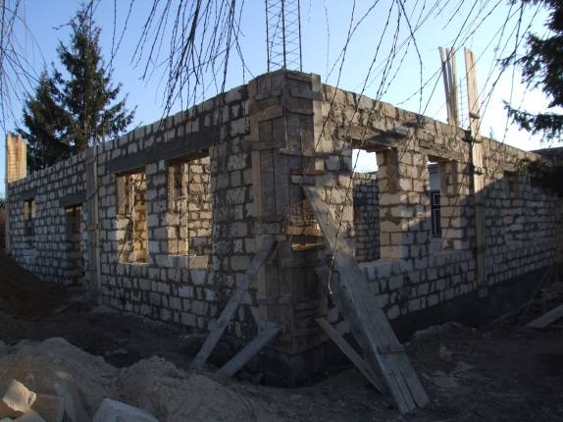Overall goals of the project:** Construction of an additional annex and reconstruction of existing roof. The kindergarten hosts 60 children from different social groups, but additional 50 children would have to be hosted after the reconstruction.

**Status: ongoing, to be compelted in June of 2013**

The project team has helped to establish the local implementation committee, negotiated and signed the Grant Agreement with the local community. All technical estimates has been carried out, a construction company has been selected through a public tender to run the works. At the moment 30% of the works are completed.

*Construction of annex, works ongoing*

### Sub-Project 10: “Enhancing capacities for pre-school education in Pirita village, Dubasari District”.

*Annex of the kindergarten in Pirita, before*

**Implemented by:** Pirita administration, local implementation committee

**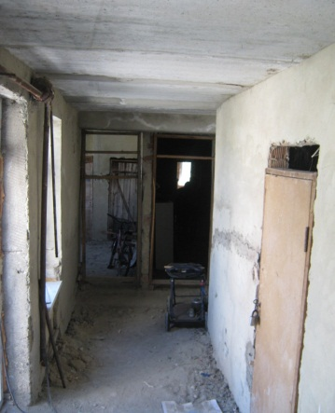Direct beneficiaries:** over 150 children and their parents from Pirita and nearby villages, local community, local authorities

**Budget:** 75,033 EUR

**Additional local contribution:** 1,875 EUR

**Timeframe:** December 2012 – May 2013

**Overall goals of the project:**

* Reconstruction of an additional annex of the existing kindergarten. The reconstruction works include replacement of windows and doors, internal sewerage and water supply systems, electricity, internal works
* 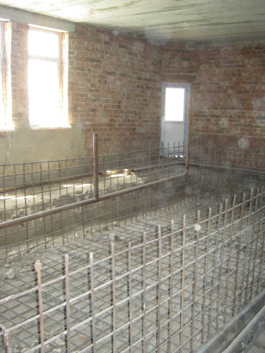The kindergarten hosts 60 children from different social groups, while the reconstruction will contribute to the creation of additional 50 new places.

**Status: on going, to be completed in June 2013**

The project team has helped to establish the local implementation committee, negotiated and signed the Grant Agreement with the local community. All technical estimates have been carried out; a construction company has been selected through a public tender to run the works. At the moment 20% of the works are completed.

*Annex of the kindergarten in Pirita, works ongoing*

### Sub-Project 11: “Promoting the confidence building measures through the reconstruction of the central road from Varnita village”

**Implemented by:** UNDPMoldovain partnership with Varnita local administration, implementation committee

**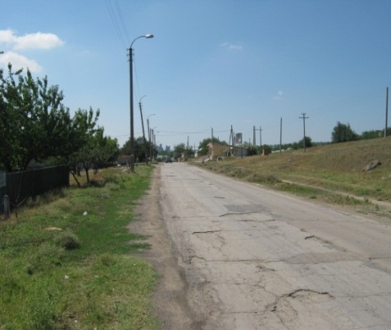**

**Direct beneficiaries:** over 15,000 people from Varnita village and the town of Bender, nearby villages in the security zone, local community

**Budget:** 108,083 EUR

**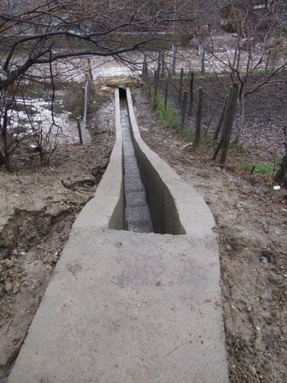Additional local contribution:** 3,125 EUR

**Timeframe:** November 2012 – May 2013

**Overall goals of the project:**

To reconstruct and modernize the main road from Varnita village, Anenii Noi district. The implementation of this project will improve access to the international route M-14 and ensure better communication between people from Bender town and Varnita village. SCBM Programme will renovate 564m out of 1250m, the total road length. The rest 686m were already renovated by the Moldovan Social Investment Fund.

**Status: on going, to be completed in May of 2013**

The project team has helped to establish the local implementation committee, negotiated and signed the Memorandum of Understanding with the Varnita village local administration. All technical estimates have been carried out; a construction company has been selected through an open tender to run the works. The reconstruction activities were started in November. 15% of the works were delivered. Reconstruction works were postponed in winter time due to the bad weather conditions.

### C:\DOCUMENTS\UNDP\SCBM\Work Plans Reports\UE reports\2012\Foto + budjet partea dreapta2\Firladeni(piata agro)-147 725,80 euro\IMG_2506.jpgSub-Project 12: “Promoting the confidence building measures through the construction square community trade in the village of Firladeni”

**Implemented by:** UNDPMoldovain partnership with Firladeni local administration, implementation committee

**Direct beneficiaries:** over 6,000 people from Firladeni, Gisca, Protegalovca, Parcani villages and the town of Bender, local authorities

**Budget:** 147,725 EUR

*Firladeni, community market, before*

**Estimated additional local contribution:** 37,500 EUR

**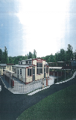Timeframe:** November 2012 – September 2013

**Overall goals of the project:**

* Structural design and construction of the new community market;
* Supporting the confidence building measures by improving and expanding the local trade activities between people from both banks of the Nistru River.

**Status: to be completed in August 2013**

The project team has helped to establish the local implementation committee, negotiated the Memorandum of Understanding with the Firladeni village local administration. A technical design company was identified through an open tender and the technical design documentation was elaborated. Accordingly to the technical project a new community market is expected to be constructed. The expected market capacity is up to 150 places.

*Expected design of the community market*

### C:\Users\natalia.djandjgava\Pictures\25.jpgSub-Project 13: “Promoting the confidence building measures through the reconstruction of the street lighting system in the village of Climautii de Jos, District of Soldanesti”

**Implemented by:** UNDPMoldovain partnership with Climautii de Jos local administration and local implementation committee

**Direct beneficiaries:** over 2000 people from Climautii de Jos village, local authorities

**Estimative Budget:** 60,000 EUR

**Timeframe:** December 2012 – June 2013

*Climautii de Jos, street lightning before*

**Overall goals of the project:** The reconstruction of the streets lighting system for the villages of Climautii de Jos. The streets lighting project will help the community budget save considerable funds and will increase visibility during the night time which will also increase the attractiveness of the villages. The total length of the lighting system exceeds 5 km.

**Status: on-going, to be launched in April 2013**

The project team has helped to establish the local implementation committee, negotiated the Memorandum of Understanding with the Climautii de Jos village local administration. A technical design company was identified through an open tender to run structural design works. At the moment the project is in the process of technical design elaboration.

### Sub-Project 14: “Promoting the confidence building measures through the reconstruction of the street lighting system in the village of Ustia, District of Dubasari”

**Implemented by:** UNDPMoldovain partnership with Ustia local administration, implementation committee

**Direct beneficiaries:** over 3700 people from Ustia village, neighbouring villages and local authorities

**Estimative Budget:** 70,000 EUR

**Timeframe:** December 2012 – June 2013

**Overall goals of the project:** The reconstruction of the streets lighting system for the villages of Ustia. The streets lighting project will help the community budget save considerable funds and will increase the streets visibility during the night time which will also will increase the attractiveness of the villages. The total length of the lighting system exceeds 12 km.

**Status: to be launched in July 2013**

The project team has helped to establish the local implementation committee, negotiated the Memorandum of Understanding with the Ustia village local administration. A technical design company was identified through an open tender to run structural design works. At the moment the technical design documentation is in the process of development and to be finished until the end of March 2013. The installation of streets lighting system is expected to be finished until the end of June 2013.

### Sub-Project 15: “Building opportunities for pro-health education in Criuleni town”

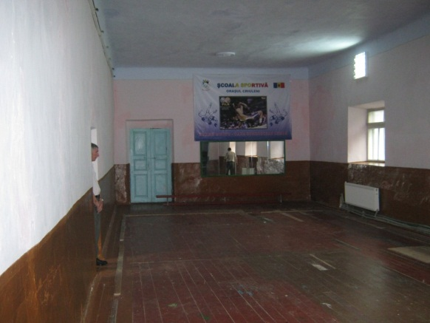

**Implemented by:** UNDPMoldovain partnership with Criuleni district administration and local implementation committee

**Direct beneficiaries:** over 8,500 people from Criuleni District and neighbouring villages from security zone.

**Estimative Budget:** 107,649 EUR

**Additional local contribution:** 11,875 EUR

**Timeframe:** November 2012 – August 2013

*Sport school, Criuleni, before*

**Overall goals of the project:**

* The capital reconstruction of the sport school from the town of Criuleni. Replacement of roof, windows, doors, water supply and sewerage systems, internal and external works.
* Organization of sport activities for children from both banks of the Nistru River.

**Status: to be launched in 2013**

The project team has helped to establish the local implementation committee, negotiated the Memorandum of Understanding with the local authorities. A technical design company was identified through an open tender to run structural design works. The technical design documentation was developed. The reconstruction activities are expected to be finished until the end of July 2013.

### Sub-Project 16: “Building opportunities for pro-health education in Chircaiesti village, Causeni district”

**Implemented by:** UNDPMoldovain partnership with Chircaiesti administration, implementation committee

**Direct beneficiaries:** 3,500 people from Chircaiesti and neighbouring villages from security zone.

**Estimative Budget:** 112,500 EUR

**Additional local contribution:** 10,000 EUR

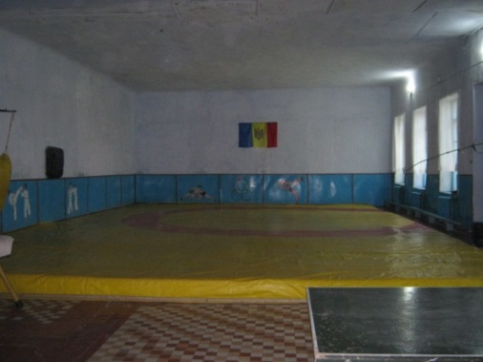**Timeframe:** November 2012 – August 2013

*Sport school, Chircaiesti town, before*

**Overall goals of the project:**

* The capital reconstruction of the sport school from the village of Chircaiesti. Replenishment of roof, windows, doors, water supply and sewerage systems, internal and external works.
* Organization of sport activities for children from both banks of the Nistru River.

**Status: to be launched in 2013**

The project team has helped to establish the local implementation committee, negotiated the Memorandum of Understanding with the local authorities. A technical design company was identified through an open tender to run structural design works. The technical design documentation was developed. The reconstruction activities are expected to be finished until the end of July 2013.

### Sub-Project 17: “Enhancing capacities of general education through the reconstruction of Puhaceni village’s lyceum, Anenii Noi District”

**Implemented by: UNDP Moldova in partnership with** Puhaceni local administration and local implementation committee

**Direct beneficiaries:** over 400 students from Puhaceni and nearby villages in the security zone, local community

**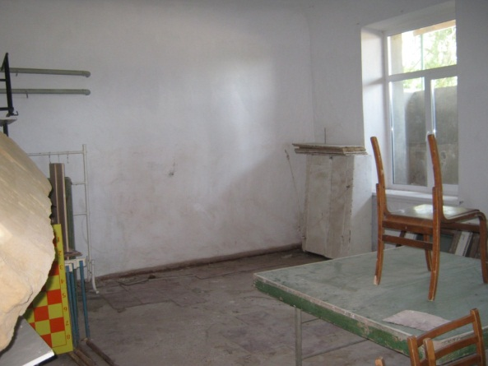**

**Budget:** 111,875 EUR

**Timeframe:** December 2012 – August 2013

**Overall goals of the project:**

* The capital reconstruction of ground floor, basement 280 m, replacement of doors and windows, furniture, etc.
* Promoting confidence building activities through organising summer camp events involving children from both sides of Nistru River.

*Puhaceni village lyceum, present status*

**Status: on-going, to be launched in 2013**

The project team has helped to establish the local implementation committee, negotiated the Memorandum of Understanding with the local authorities. A technical design company was identified through an open tender to run structural design works. The technical design documentation was developed. The reconstruction activities are expected to be finished until the end of July 2013.

### Sub-Project 18: “Promoting a pro-environment water management in Cioburciu village, Stefan Voda District”

**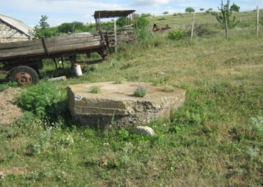Implemented by:** UNDP Moldovain partnership withCioburciulocaladministration, local implementation committee

**Direct beneficiaries: over** 2800people from local community, local authorities

**Estimative budget:** 109,222 EUR

**Additional local contribution:** 10,500 EUR

**Timeframe:** December 2012 – June 2013

*Old artesian well in Cioburciu village*

**Overall goals of the project:** Reconstruction of the water system in the village, including one artesian well and provide water to 40% of households and social institutions.

**Status: to be launched in 2013**

The project team has helped to establish the local implementation committee, negotiated the Memorandum of Understanding with the Cioburciu village local administration. A technical design company was identified through an open tender to run structural design works. At the moment the technical design documentation is in the process of development and to be finished until the end of March 2013. The reconstruction of the water supply system is expected to be finished until the end of June 2013.

### C:\Users\natalia.djandjgava\Pictures\30.jpgSub-Project 19: “Promoting a pro-environment sewerage management in Holercani village, Dubasari district”

*Holercani village, problematic segment of sewage*

**Implemented by:** Holercanilocaladministration, local implementation committee

**Direct beneficiaries:** over 2800people from local community, adjacent communities, local authorities

**Estimative Budget:** 112,440 EUR

**Additional local contribution:** 9,750 EUR

**Timeframe:** November 2012 – May 2013

**Overall goals of the project:**

* The reconstruction of the sewerage system and installation of the treatment plant.
* *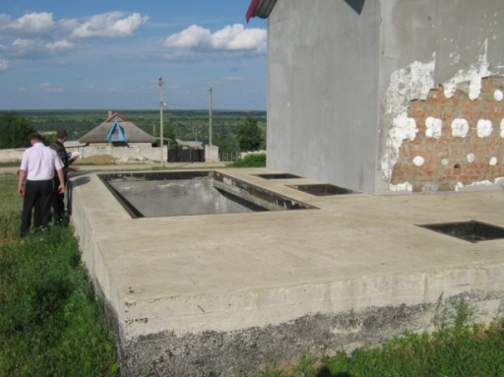*Connect several public institutions and over 200 households to sewerage system and wastewater treatment plant to avoid damages on the environment.

**Status: to be launched in June 2013**

The project team has helped to establish the local implementation committee, negotiated and signed the Grant Agreement with the local community. All technical estimates have been carried out. The local authorities are still in the process of selection of the construction companies. The first public tender failed due to insufficient number of qualified bid proposals. The reconstruction of the sewerage system is expected to be completed until the middle of May 2013.

*Reconstruction of sewerage system ongoing*

### Sub-Project 20: “Enhancing capacities of the public health services from Criuleni through renovation of the Paediatric Department of the Criuleni District Hospital”.

**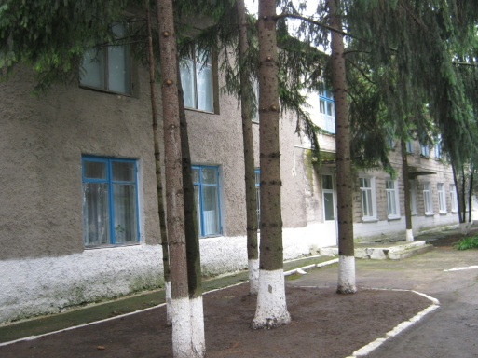Implemented by:** Criuleni District administration, local implementation committee

**Direct beneficiaries:** over 10 000 people from Criuleni and Dubasari Districts, adjacent communities from TN region, local authorities

**Estimated Budget:** 91,854 EUR

**Additional local contribution:** 10, 000 EUR

**Timeframe:** December 2012 – June 2013

*Criuleni hospital*

**Overall goals of the project:**

* Capital reconstruction of Paediatric Department.
* Contribute to experience exchange between Criuleni and Dubasari health institutions as a strong confidence building element.

**Status: to be launched in 2013**

The project team has helped to establish the local implementation committee, negotiated and signed the Grant Agreement with the local community. All technical estimates have been carried out. The local authorities are still in the process of selection of the construction companies. The first public tender failed due to insufficient number of qualified bid proposals. The reconstruction of the Paediatrics Department is expected to be completed until the end of June 2013.

### Sub-Project 21: “Promoting the confidence building measures by renovating streets in Vasilievca village, Cocieri Mayoralty, Dubasari District”

*Vasilievca streets*

**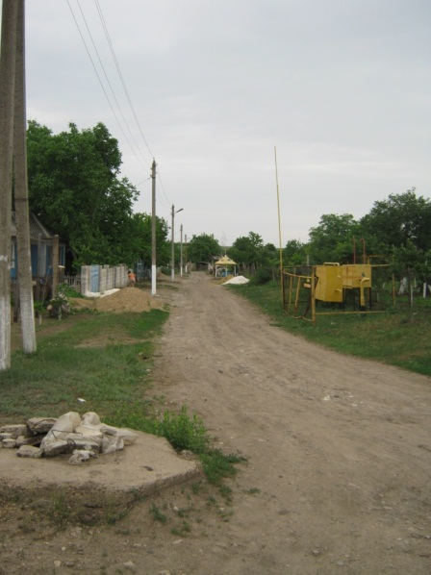Implemented by:** UNDPMoldovain partnership with Cocieri and Vasilievca local administration and local implementation committee

**Direct beneficiaries:** over 100 people from Vasilievca and Cocieri village and the town of Bender, nearby villages in the security zone, local community

**Estimative Budget:** 61,983 EUR

**Timeframe:** October 2012 – May 2013

**Overall goals of the project:**

* The renovation of the main streets from Vasilievca village (1250 m).
* Promote confidence building measures through increasing the attractiveness of the localities from the security zone under the Republic of Moldova jurisdiction.

**Status: to be launched in 2013**

The project team has helped to establish the local implementation committee, negotiated the Memorandum of Understanding with the Cocieri Mayoralty. All technical estimates have been carried out. Taking into consideration the isolated location of Vasilievca village and the risk of blocking the process of reconstruction by the authorities from TN region, the tender for the selection of the construction company was postponed due to uncertainty regarding the implementation modality and mechanism. During the last two months the implementation of this project in Vasilievca village was negotiated with the authorities from TN region and preliminary agreement was received.

### Sub-Project 22: “Enhancing capacities of the public social protection services from Dubasari District through creation of the Social Home for Elderly People from Oxentea village”.

**To be implemented by:** Oxentea local administration, local implementation committee

**Direct beneficiaries:** old people from Oxentea village, adjacent communities, local authorities

**Estimated Budget:** 100,875 EUR

**Overall goals of the project:** Technical design and capital reconstruction of Social Home for Elderly People.

**Status:** Immediately after the approval of the project proposal by the Steering Committee the project team has helped the local community to establish a local implementation committee. The grant agreement has not been signed due to the fact that the local authorities failed to provide the agreed premises for reconstruction. The launching of the project remains uncertain.

**Infrastructural projects from TN Region**

*Tibuleuca kindergarten, before*

### D:\UNDP\SCBM\Work Plans Reports\UE reports\2012\Foto + budjet partea dreapta2\TN Tibulievca(gradinita)-111 736,88 euro\IMG_2587.JPGSub-Project 23: “Enhancing capacities for pre-school education in Tibuleuca village, Dubasari district”.

**Implemented by:** Tibuleuca kindergarten, local implementation committee

**Direct beneficiaries:** over 150 children and their parents from Tibuleuca village, local community

**Budget:** 111,137 EUR

**Timeframe:** December 2012 – May 2013

**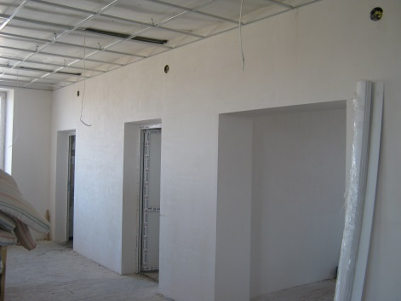Overall goals of the project:** Capital repair of the second floor of the kindergarten from Tibuleuca village. The kindergarten hosts 50 children from different social groups, but additional 50 children will be hosted after the reconstruction.

**Status: on-going, to be completed in May of 2013**

The project team has helped to establish the local implementation committee, negotiated and signed the Grant Agreement with the kindergarten. All technical estimates have been carried out; a construction company has been selected through a local tender to run the works. The reconstruction activities include replacement of floor, windows and doors, internal works, renovation of internal and external sewerage system, electricity and furnishing.

*Tibuleuca kindergarten works on-going*

### Sub-Project 24: “Enhancing capacities for pre-school education in the city of Tiraspol through reconstruction of the kindergarten nr.44 for visually impaired children”.

**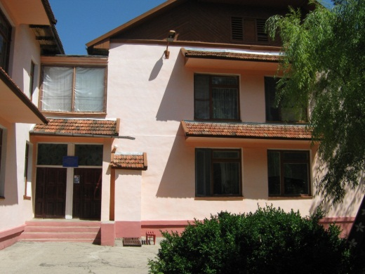**

**Implemented by:** kindergarten administration, local implementation committee

**Direct beneficiaries:** over 200 visually impaired children and their parents from Tiraspol, local community

**Budget:** 111,263 EUR

**Timeframe:** December 2012 – June 2013

**Overall goals of the project:** Capital repair of the heating and sewerage systems. The necessary equipment pieces for the kitchen and the laundry follow to be purchased, the windows and doors will be replaced and finishing works will be performed.

*Kindergarten 44, Tiraspol, present status*

**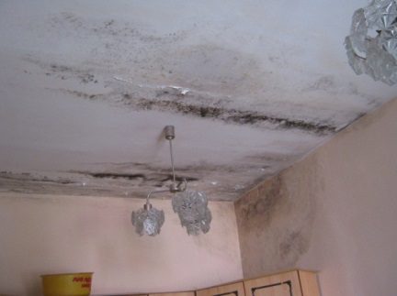**The kindergarten № 44 from Tiraspol for visually impaired children is a special care and education center for visually impaired children from Transnistria with a total surface of 1500m². The roof is leaking, the heating system is hardly functioning, the windows are rotten, and the furniture and equipment are obsolete. The roof, the heating and sewerage systems will be renovated by SCBM programme. The necessary equipment for the kitchen and the laundry are to be purchased, the windows and doors will be replaced and finishing works will be performed.

*Kindergarten 44, present status*

**Status: to be launched in 2013**

The project team has helped to establish the local implementation committee, negotiated and signed the Grant Agreement with the institution. All technical estimates have been carried out; a construction company has been selected through a local tender to run the works. The reconstruction activities are expected to be completed in June 2013.

### Sub-Project 25: “Enhancing capacities for pre-school education in Ternovca village, Slobozia district”.

**Implemented by:** Ternovca administration, local implementation committee

**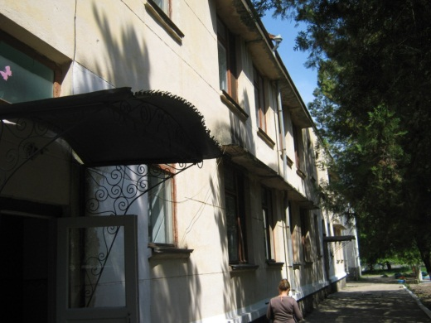Direct beneficiaries:** over 350 children and their parents from Ternovca village, local community

**Budget:** 111,471 EUR

**Timeframe:** December 2012 – June 2013

**Overall goals of the project:**

* Capital repair of the roof, replacement of windows and doors, some indoor finishing works will to be performed. The kitchen, the ventilation system and the electricity facilities will be renovated.

*Kindergarten in Ternauca, before*

* **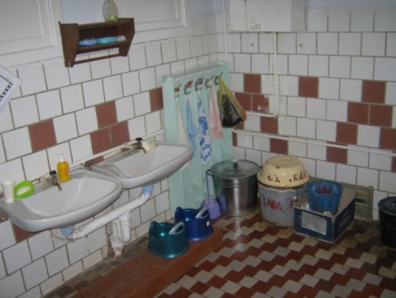**Two new group rooms are planned to be renovated and some equipment will be purchased.

*Sanitary unit, present status*

**Status: to be launched in 2013**

The project team has helped to establish the local implementation committee, negotiated and signed the Grant Agreement with the local social institution. All technical estimates have been carried out. The local administration is still in the process of selection of the construction company. The first public tender failed due to insufficient number of qualified bid proposals. The reconstruction activities are going to be completed in July 2013.

### Sub-Project 26: “Building opportunities for pro-health education in Grigoriopol town”

**Implemented by:** Grigoriopol administration, local implementation committee

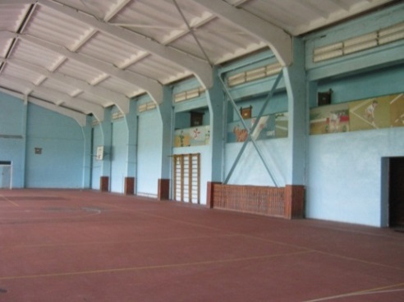**Direct beneficiaries:** 670 school students from the children & youth sport school and 1200 pupils from the school №2 of Grigoriopol, local community

**Budget:** 112,025 EUR

**Timeframe:** December 2012 – July 2013

**Overall goals of the project:**

* General renovation of Children and Youth Sport School from the town of Grigoriopol.
* Organization of sport activities for children from both banks of the Nistru River.

*Sport school, Grigoriopol, present status*

**Status: to be launched in March 2013**

The project team has helped to establish the local implementation committee, negotiated and signed the Grant Agreement with the local institution. All technical estimates has been carried out the construction company was selected through a local tender. The reconstruction activities will be completed in July 2013.

### Sub-Project 27: “Enhancing capacities of general education through the reconstruction of Butor village school, Grigoriopol district”

**Implemented by:** Butor administration, local implementation committee

**Direct beneficiaries:** 350 school students from the village of Butor, local community

**Estimated Budget:** 115,582 EUR

**Expected additional local contribution:** 20,000 EUR

**Timeframe:** December 2012 – August 2013

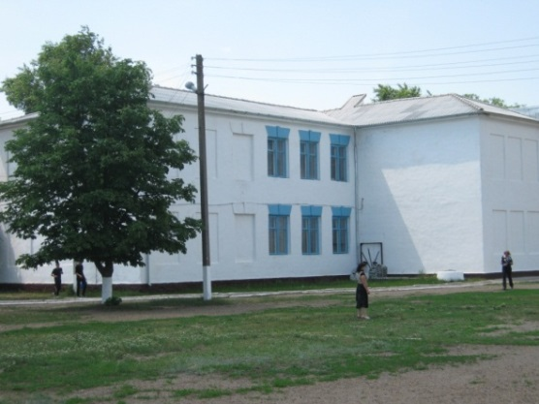**Overall goals of the project:** The construction of the new school kitchen.

**Status: to be launched by March of 2013**

The project team has helped to establish the local implementation committee, negotiated and signed the Grant Agreement with the local institution. All technical estimates have been carried out the construction company was selected through a local tender. The reconstruction activities are going to be completed in July 2013.

### Sub-Project 28: “Building opportunities for pro-health education in Parcani village, Slobozia district”

*Butor village school, present status*

**Implemented by:** Parcani local community, local implementation committee

**Direct beneficiaries:** over 2,000 children and students from Parcani village, local community

**Budget:** 111,214 EUR

**Timeframe:** December 2012 – July 2013

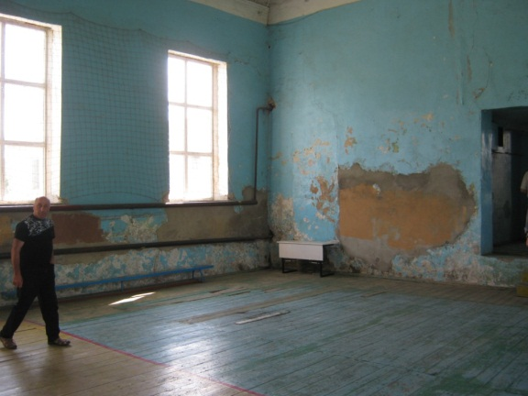**Overall goals of the project:**

* General renovation of Children and Youth Sport School from Parcani village.
* Organization of sport activities for children from both banks of the Nistru River.

**Status: to be launched in March of 2013**

The project team has helped to establish the local implementation committee, negotiated and signed the Grant Agreement with the local institution. All technical estimates have been carried out. SCBM programme is going to realize the indoor finishing works and to replace the internal networks, as well as some sports equipment follow to be purchased. The local administration is still in the process of selection of the construction company. The first public tender failed due to insufficient number of qualified bid proposals. The reconstruction activities are going to be completed in July 2013.

*Parcani village, Children and Youth sport school, present status*

### Sub-Project 29: “Enhance Women's Economic Empowerment in communities on both banks of Nistru River”

**Implemented by:** UN Women

**Estimative Budget:** EUR 187,500

**Timeframe:** February 2013 – May 2014

**Overall goals of the project:** to support women’s economic empowerment and improve local governance by increasing access of rural women to information and public services including employment and social protection services in Dubasari district.

**Direct beneficiaries:** women living in villages where infrastructure projects are being implemented, local community, women and vulnerable people from the Dubasari district

**Local government in Dubasari district** – advocate introduction of joint coordination service provision and access to information for women and vulnerable groups of population

**Local Service Provider and Local Public administration level 1** (mayoralty) – enhance capacity of local service providers to deliver high quality services for women and vulnerable groups of population and increase capacity of mayoralties in identifying needs of vulnerable.

Due to the nature and scope of the program, **project partners** will be: local government in Dubasari district, local service providers both from deconcentrated and decentralized service, Mayoralties, local CSOs and gender equality advocates for the implementation of specific activities in both district and rural settings. In addition, the project will have recourse to local and international expertise as required and utilize and benefit from on-going UN Women initiatives implemented in Moldova.

The project has two main outputs:

* **Output 1:** Capacity of local service providers strengthened to provide services for rural women in a coordinated way through Joint Information and Services Bureau
* **Output 2:** Capacity of national partners to implement gender-sensitive infrastructure community and social projects within UNDP CBM programme strengthened

As part of the output one it is proposed to: facilitate establishment and functioning of Coordinated Service provision in Dubasari district, as a first entry point for improving service provision for local population, including population of the Transnistria region, and increase confidence and generate interest towards integrated service provision on both banks of Nistru River.

To support realization of the second output and effectively mainstream gender in community empowerment and social projects within CBM Program implemented by UNDP, UN Women will strengthen the capacity of partners implementing infrastructure community and social projects (local public authorities, local implementation committees, beneficiary institutions) to undertake gender assessment and ensure that women and men equally benefit from implemented projects.

The project will directly support further realization of the women’s rights and gender equality commitments undertaken by Moldova at international as well as national levels and will upscale results achieved by the country**.**

**\*\*\***

## 5.2.2 Integration of health specialist care - Support to Strengthening Perinatal Care and Immunizations in Transnistrian region

**Implemented by:** WHO, UNICEF

**Budget:** $250,000.00 (WHO); $270,000.00 (UNICEF)

**Status**: Activities will be initiated in April-May 2013

An inter-agency Agreement was signed. Based on this agreement it is proposed to conduct an assessment of the hospital care for mothers and new-borns; as well as an assessment of the antenatal care for mothers and new-borns by WHO; while UNICEF will work on building the capacity of the professionals from the perinatal centres in Effective Perinatal Care; as well as carry on awareness raising activities. The need for procurement of the equipment and renovation of the medical units by UNICEF and UNDP will be determined following the above mentioned assessments. As for Immunizations, two technical assistance missions per year will be conducted by WHO, as well as the development of a more specific phase out action plan for GAVi graduation and plan of action to improve the immunization coverage rates. UNCIEF will purchase selected supplies needed to improve vaccination coverage levels; while capacity building and awareness raising activities are to be conducted by the two UN agencies jointly (European Immunization Week, crisis communication etc.)

## 5.2.3 Environmental projects

In line with the overall philosophy of the program, the environmental component will be carried out through a partnership of organizations from both banks. The project has conducted consultations with both sides, including NGOs and representatives of the line institutions to obtain a broad analysis of the situation, identify key problems in this sector and to zoom down on some very specific priority areas that affect both sides and that, if addressed through joint work, could provide clear benefits for the people on both banks.

As a result of these consultations, several priority areas have been identified, including water waste treatment facilities along the Dniester, air quality meters to measure air quality in the industrial zones and control air pollution (such as Rybnitsa and Rezina), waste management and the quality of drinking water. Site visits have been conducted to assess some of these projects and narrow down the list of possible areas of interventions.

Further to the development of a short list of potential interventions, consultants or consulting company will be engaged to conduct in –depth assessments and/or feasibility analysis for project implementation. Guidance of the SCBM Programme Board will be considered at each of these stages.

\*\*\*

## 5.3. CIVIL SOCIETY COMPONENT

Civil society projects are aimed at supporting links between communities and people, as well as fostering cooperation between key actors from the two sides and establishing cross-river NGO partnerships. Under this component, organizations from both banks of the Nistru River have been encouraged to develop joint projects in order to respond to pressing social and community needs and address human rights issues. Through projects implemented in the first year of the programme, NGOs from both banks have boosted their capacities for joint work, exchanged experience and shared best practices in key development and human rights areas.

**Foster civil society development in the Transnistria**

At the first Programme Board Meeting on 11th of April, 2012, the **Concept of Selecting and Implementing the joint Civil Society Projects** has been approved. Based on this, **two rounds of calls for proposals** have been conducted, inviting active NGOs from both banks of the river to establish partnerships and propose joint projects in the following **thematic areas**: media, arts & culture, research and analysis, democratic values, community participation, human rights, environment and project to address pressing community needs and facilitate access to social services.

The rules for projects proposals submission, evaluation and implementation had been set out in the **Guidelines for Applicants’** which were posted together with the application form at UNDP’s web site, [www.undp.md](http://www.undp.md), as well as sent directly to most NGOs from both banks. The announcement has been thoroughly discussed and explained to NGOs during multiple meetings, information sessions and face-to-face events. It was also widely communicated through colleagues from other development agencies and Embassies. In order to ensure tangible impact, the program invited projects under **two streams of grants**: grants for organizations with extensive experience in project implementation (total project ceiling up to 100,000 USD) and small grants (total project ceiling up to 25,000 USD).

As a result of two grants competitions, the first one organized in May 2012 and the second in November 2012, **213 proposals have been received** (96 in the first call for proposals and 117 in the second call for proposals). A thorough pre-selection process was conducted by the Project team, including compliance review, assessment against the evaluation criteria and the Call for Proposals requirements. Short and factual assessment notes have been presented to the Evaluation committee, which then assessed shortlisted project proposals against several selection criteria, the key being: 1) to what extent the project idea is innovative and contributes to improving the situation on the ground in a given area, 2) to what extent it involves meaningful joint work of institutions, NGOs, communities and people from both banks, and 3) to what extent it is feasible and realistic. As a result of a thorough participatory process, 12 projects have been approved for funding during the SCBM Programme Board held on July 5, 2012 under the first Call for Proposals. Under the second call for proposals, 9 projects have been selected by a representative Evaluation Committee and will be proposed for funding to the Programme Board on March 27, 2013.

**Number of Sub-Projects: 12**

## 5.3.1. Civil Society Sub-projects

**Total budget committed for sub-projects: $672,310.40.**

**1-st STREAM FOR ESTABLISHED ORGANIZATIONS (UP TO USD 100,000)**

### C:\Users\natalia.djandjgava\Pictures\c1.jpgSub-project 1: **„Modern media across Nistru”**

**Implemented by:** “Association for Development and Cooperation” in partnership with “Publika TV” station

**Project budget:** 78,460.00 USD.

**Project timeframe:** July 24, 2012 – December 31, 2012.

**Beneficiaries:** The direct beneficiaries of the project are 20 journalists from both banks of the Nistru River, aged 22-35 years. Beneficiaries are also citizen of Moldova, including viewers of Publika TV and media institutions whose journalists participated in the media trainings from the Transnistrian region.

*Joint media training at Publika TV studio*

**Project’s geographic area**: Chisinau, Tiraspol, Bender, Comrat, Cimislia, Soroca, etc.

**Overall goal of the project:** Contribute to cooperation between media professionals from both banks of Nistru River, increasing their professional level of journalistic skills through trainings provided by well-known practitioners and offering hands-on experience to TV journalists from both banks of Nistru River.

**Status:** **Project Completed, delivery – 100%.** The project was finalized, reports submitted and approved as of December 2012. All activities were carried out in accordance with the project document and the initial work plan. The project was assessed positively against the initially foreseen results, as well as the grantee’s strong capacity to implement projects/grants.

**Project’s results:**

* 20 journalists from both banks trained in joint professional news and information programs production for TV, radio and on-line regional media outlets from Moldova and Transnistrian region.
* The group of 20 men and women journalists from both banks and Gagauz Yeri have spent two weeks in Publika TV studio having been coached by 25 most professional local and foreign media practitioners on: shooting technics, diction rules, investigative journalism, video editing, news writing, stand-ups, on-line media and radio peculiarities.
* About 180 news spots, 90 TV reports have been shot and broadcast on social, economic and political topics, including local and central public authorities’ official sessions and public events of general interest to the viewers.
* Professional, non-political bridges between the 20 journalists have been established within a social media group registered on Facebook which already gathered about 80 members: <http://www.facebook.com/home.php#!/groups/367039486704942/?fref=ts> .
* The best practices, new skills and knowledge are being shared in the daily journalistic operations of the 20 regional media outlets from both banks which journalists have attended these trainings.

**PRESS clippings**

<http://www.youtube.com/watch?v=QOImpOKSB7c&feature=player_embedded>

<http://www.facebook.com/ModernMediaAcrossNistru>

<http://www.publika.md/se-lanseaza-scoala-de-jurnalism-publika---modern-media-across-nistru_959701.html>;

<http://www.publika.md/cum-poti-deveni-elev-al--scolii-de-jurnalism-publika---modern-media-across-nistru_959761.html>;

<http://www.publika.md/scoala-de-jurnalism-publika---modern-media-across-nistru-isi-asteapta-elevii--inscrie-te-si-tu_969421.html>;

<http://nr2.ru/pmr/404324.html>;

<http://www.allmoldova.com/ro/moldova-news/1249066014.html>

<http://www.bb2day.eu/moldova/society/6352-moldova-confidence-building-between-journalists-from-both-banks-of-the-nistru-river.html>;

<http://www.undp.md/presscentre/2012/CBM_14September/index.shtml>

### Sub-project 2**: “Enhancing media capacity in Moldova and the Transnistrian region”**

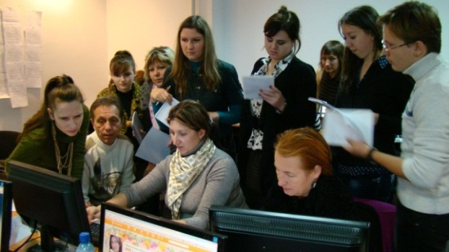**Implemented by:** “Independent Journalism Center” in partnership with “Media Center” and “Stels-Tera” NGOs from Tiraspol

**Project budget: 84,218.9 USD**

**Project timeframe: July 24, 2012 –July 23, 2013**

**Beneficiaries:** 15 media outlets and 5 NGOs from the Transnistrian region; 20 journalists (10 from each bank) who participated in multimedia training; 50 pupils and 10 teachers from ten public schools who participated in online/journalism training.

*On-gong training in multimedia*

**Project’s geographic area:** Chisinau, Tiraspol, Bender, Rybnitsa, Grigoriopol, Dubasari, Comrat.

**Overall goal of the project:** To equip media organizations and journalists from the Transnistrian region with tools to boost their development and improve their editorial policies, provide professional trainings and new types of management, thus creating favourable conditions for a vibrant media to take hold in the region.

**Project status: On-going. Delivery-90%.**

**Project’s results:** 63 beginner journalists, pupils from Transnistrian schools trained in blogging

* 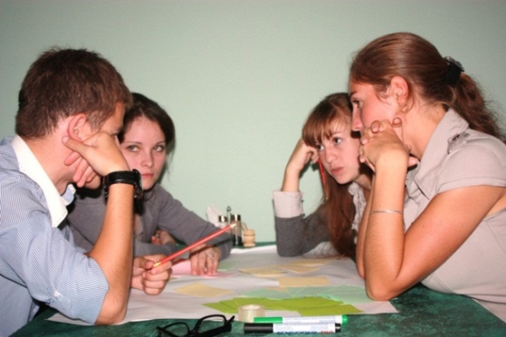11 blogs created and maintained for the community schools from Ternovka, Sucleia, Malaiesti, Bender, Gyska, Parkani, 2 schools from Rybnitsa, Hrustovaya, Dubasari and Lunga where information about their day to day schools life is being shared.

<http://sschools.wordpress.com/>

<http://schoolife15.wordpress.com>

<http://schoolternovka.wordpress.com/>

<http://parcany1.wordpress.com/>

<http://rybgimnazia.wordpress.com/>

<http://school2best.wordpress.com>

<https://lungaschool7.wordpress.com>

<http://ongmalaiesti.wordpress.com/>

<http://ouryouth6.wordpress.com>

<http://benderyshkola20.wordpress.com/>

<http://hrustovayashkola.wordpress.com>

*Pupils reflecting on their school blog content*

* 20 professional journalists from both banks trained in multimedia; 10 joint multimedia products combined by elements of print media with photos, video, sounds, and graphics are under realization at this stage by this mixed group of 20 advanced journalists from both banks.
* A “media needs assessment study” in Transnistria Region with the involvement of local and international media experts offering up-to-date, relevant data about media situation in Transnistrian region is being developed for the further use of media NGOs, journalists, public authorities, donor community and international organizations.
* 28 meetings with journalists, editors, media and NGO managers have been conducted in Chisinau and Transnistrian region for the media needs assessment study.

**PRESS clippings:**

<http://www.ijc.md/index.php?option=com_content&task=view&id=738&Itemid=1>

<http://www.ijc.md/index.php?option=com_content&task=view&id=729&Itemid=1>

<http://www.comunicate.md/index.php?task=articles&action=view&article_id=5765>

<http://www.civic.md/stiri/comunicate/17988-cji-lanseaza-un-proiect-complex-pentru-jurnalistii-din-regiunea-nistreana.html>

<http://www.civic.md/anunturi/arhiva-anunturilor/18359-elevii-din-mlieti-si-sucleia-initiai-in-blogging.html?device=iphone>

<http://ong.md/index.php?mact=News,cntnt01,detail,0&cntnt01articleid=1982&cntnt01returnid=70>

<http://www.niuzer.ro/Republica-Moldova/Elevii-din-Malaiesti-si-Sucleia-initiati-in-blogging-4591408.html>

<http://www.undp.md/presscentre/2012/CBM_20September/index.shtml>

<http://www.facebook.com/groups/119799811369259/>

<http://www.facebook.com/groups/428715763842085/>

<http://www.ijc.md/index.php?option=com_content&task=view&id=764&Itemid=1>

<http://www.ijc.md/index.php?option=com_content&task=view&id=761&Itemid=1>

<http://www.ijc.md/index.php?option=com_content&task=view&id=749&Itemid=1>

<http://www.ijc.md/index.php?option=com_content&task=view&id=746&Itemid=1>

<http://www.ijc.md/index.php?option=com_content&task=view&id=755&Itemid=1>

<http://www.undp.md/presscentre/2012/CBM_20November/index.shtml>

<http://www.politik.md/?view=articlefull&viewarticle=13381>

<http://www.civic.md/stiri/comunicate/18963-elemente-ale-presei-on-line-studiate-de-jurnalisti.html>

<http://www.civic.md/stiri/comunicate/18976-programul-de-instruire-in-blogging-continua.html>

<http://www.civic.md/comunicate/18485-un-nou-program-de-instruire-pentru-elevii-din-regiunea-nistreana.html>

<http://www.comunicate.md/index.php?task=articles&action=view&article_id=5980>

<http://www.comunicate.md/index.php?task=articles&action=view&article_id=6228>

<http://comunicate.md/index.php?task=articles&action=view&article_id=6219>

<http://www.comunicate.md/index.php?task=articles&action=view&article_id=5980>

<http://news.click.md/item/un-nou-program-de-instruire-pentru-elevii-din-regiunea-nistreana-3416031>

<http://news.click.md/item/elevii-din-scolile-transnistrene-invata-bloggingul-la-tiraspol-4068984>

<http://tatianarosca.wordpress.com/2012/10/03/elevii-pasesc-in-lumea-blogurilor/>

<http://www.infoprut.ro/tag/bloguri-pentru-elevii-din-regiunea-transnistreana>

<http://www.ispri.ro/?p=3244>

<http://www.niuzer.ro/Republica-Moldova/Un-nou-program-de-instruire-pentru-elevii-din-regiunea-nistreana-4645982.html>

<http://news.yam.ro/ro/story/1074436>

<http://www.stiri-azi.ro/ziare/articol/articol/elevii-pasesc-in-lumea-blogurilor/sumar-articol/81580789/>

<http://www.stiri-azi.ro/ziare/articol/articol/elemente-ale-presei-on-line-studiate-de-jurnalisti/sumar-articol/89700454/>

### Sub-project 3: „ Road safety and casualty reduction”

**Implemented by:** Automobile Club of Moldova in partnership with the Automobile Club from Transnistrian Region and Eastern Alliance for Safe and Sustainable Transport from the United Kingdom

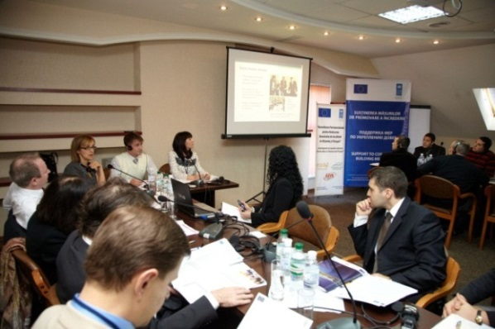

**Project budget: 79,600 USD**

**Timeframe: July 24, 2012 – July 23, 2013**

**Beneficiaries:** Public servants, roads police, emergency service, media and education institutions. 8 project staff – 4 from Chisinau and 4 from Tiraspol that are directly working with the two Automobile Clubs in both municipalities. The beneficiaries of the project are also population of Chisinau (700,000) and Tiraspol (150,000) who will benefit from new casualty reduction strategies and opportunities at local level.

*Joint training on roads safety*

**Project geographical area:** Chisinau, Tiraspol, London.

**Overall goal of the project:** To contribute to the development of local casualty reduction partnerships based on a new roads safety approach, an issue of critical public concern in Moldova and Transnistrian region.

**Project Status: On-going, Delivery-90%**

**Project’s results:**

* A training in roads safety and 6 follow up workshops were organized during October-December 2012 that gathered representatives from the road police, municipal transport department, Ministry of Education and Youth, Health Ministry, Emergency Service, media, civil society and international community representatives from Chisinau and Tiraspol and foreign experts from UK, Ukraine and Armenia.
* A common vision on the opportunity to develop initiatives similar to those from Great Britain in Chisinau and Tiraspol has been elaborated to reduce the number of road accidents, based on an innovative approach of the road safety on both banks.
* A roads safety report about the situation in Chisinau and Tiraspol has been elaborated, published and discussed during public meetings and distributed to interested actors.
* One of the report findings was the estimation of each life lost on the roads of Moldova „costs” the national economy about 511,000 USD. More than that 41.80% of the total number of car accidents are happening in Chisinau, in which hundreds of people lose their lives.

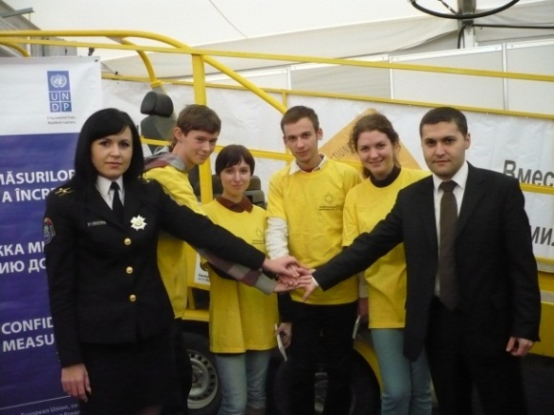**PRESS clippings:**

<http://ukinmoldova.fco.gov.uk/en/news/?view=News&id=831038982>

<http://www.undp.md/presscentre/2012/CBM_1November/index.shtml> <http://eeas.europa.eu/delegations/moldova/press_corner/all_news/news/2012/improve_road_safety-chisinau_and_tiraspol.pdf> <http://saferoads.md/index.php?view=news&t=security_2012_exhibition> <http://saferoads.md/index.php?view=news&t=development_of_parterships_to_reduce_the_number_of_acctidents>

<http://saferoads.md/index.php?view=news&t=armenian_and_ukrainian_experience_in_developing_local_casualty>

*Seat belt slide demonstration at Moldexpo*

<http://www.easstransport.org/news/news/370>

<http://pr.gov.md/news/details/865>

<http://mediacenter.hostink.ru/iann/257-sozdanie-partnerstva-za-dorozhnuyu-bezopasnost.html>

<http://www.easstransport.org/news/news/374>

<http://www.easst.co.uk/news/news/376>

<http://www.easst.co.uk/news/news/375>

<http://saferoads.md/romana/update_september_26_2012.html>

<http://www.easstransport.org/news/news/368>

<http://saferoads.md/romana/update_october_1_2012.html>

<http://www.canal3.md/rus/news/social/item2446/#.UKP2lNXF5f8.facebook>

<http://www.publika.md/video-un-grup-de-tineri-a-desenat-zebre-la-una-dintre-cele-mai-aglomerate-intersectii-din-capitala_1138271.html>

<http://www.publika.md/publika-tv-a-organizat-un-flashmob-la-trecerea-de-cale-ferata-de-la-mereni-video_1132871.html>

<http://www.easstransport.org/news/news/352>

<http://www.easstransport.org/news/news/363>

<http://www.facebook.com/pages/Make-Roads-Safe-Moldova-Să-facem-drumurile-mai-sigure-în-Moldova/177584555591590>

<http://www.saferoads.md>

### Sub-project 4: „ Social interaction in a changing society: building trust and stability”

**Implemented by:** “New Age”, Tiraspol (Новый Век) in partnership with „Initiativa Comunității pentru Democratizare si Conciliere” from Chisinau

**Project budget: 93,290.00 USD**

**Project timeframe: July 30, 2012 – July 29, 2013**

**Beneficiaries:** A network of social researches from both banks of the river, representatives of the confidence building working groups, media representatives, decision makers, population on both sides

**Project geographic area:** Chisinau, Tiraspol, Ukraine.

**Overall goal of the project:** To create a joint social platform that would measure the opinions and the level of trust between the people living on both sides of Nistru River, with results to compared and presented to decisions makers on both side for further joint action.

**Project status: On-going, delivery 90%.**

**Project results:**

* During the joint working meeting commonly held in Chisinau and Tiraspol in September 2012 by the two implementing partners, study methodology and data tracking has been elaborated and a joint methodological platform has been set up.
* On October 11-13, 2012 a scientific-methodological seminar was held in Mereneshti, near Bender which joined 27 social researchers (18 women and 9 men) from both banks, Ukraine, Russia and EU sharing their specific experience in social researches and opinion pools methodology.
* The social pool questionnaire was developed on the general public trend, the level of social and economic well-being of the population, issues, concerns and stereotypes identification.
* The social research data which has been conducted on October 2012-January 2013 is in the process of being monitored, compared and analysed by the joint group of 50 experts from both banks.
* A poll has been conducted on a sample of 1400 respondents from the right bank, 600 from the left bank and 620 from Ukraine.
* 56% of respondents are women and 44% men.
* In addition to the social pool, the research has been completed with official statistical data provided by the Central Statistical Offices from Chisinau and Tiraspol based on a number of practical case studies for 2000-2012 years.

### Sub-project 5: „ Transnistria Conflict Resolution Task Force”

**Implemented by: “Carnegie Endowment for International Peace” Washington, D.C., USA**

**Beneficiaries:** 26 participants from both banks of the Transnistria Conflict Resolution Task Force

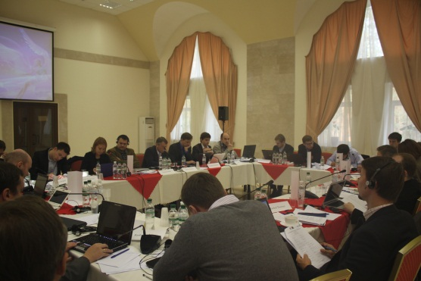**Approved budget:** 92,000.00 USD

**Timeframe:** July 24, 2012 - July 23, 2013

**Project geographic area:** Chisinau, Tiraspol, Kiev, Washington.

**Overall goal of the project:** The Task Force brings together a core group of civil society experts representing all sides in the conflict for a series of biannual discussions on building trust and confidence. Through an open exchange of views, concerns, and recommendations, participants develop a nuanced understanding of the conflict from multiple perspectives and embrace a spirit of compromise needed to achieve a peaceful resolution. Recommendations and ideas are then shared with the leadership of all sides.

*Conflict Resolution Task Force meeting in Kiev*

**Status: On-going, Delivery-90%.**

**Project’s results:**

* 26 participants of the Transnistria Conflict Resolution Task Force, civil society experts from all stakeholders involved in the 5+2 process discussed ways of achieving a peaceful settlement of the Transnistria conflict during the meeting in Kiev held in October 2012 having the aim to agree on recommendations regarding Transnistria conflict resolution that could be implemented during Ukraine’s chairmanship of the OSCE.
* The participants discussed a range of vital issues
* The conference participants were able to agree upon several concrete recommendations for Ukraine to undertake during its upcoming chairmanship of the OSCE.
* Meetings with key government officials from Moldova and Ukraine took place to establish a working relationship with senior government officials and to provide them with recommendations for moving forward on conflict resolution in Transnistria.
* During the meeting itself, Task Force members discussed in depth the possible composition and work of “working groups” on sub-topics, including regional reconciliation and practical confidence-building measures.

### Sub-project 6: „ European Integration and Conflict Settlement in Moldova-Transnistria

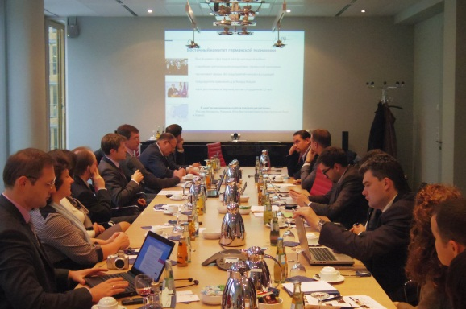**Implemented by:** “Crisis Management Initiative”, Finland

**Project budget:** **94,782.00 USD**

**Project timeframe:** July 24, 2012 – December 31, 2012

**Beneficiaries:** A mixed group of professionals from Moldova and Transnistria region - a core group of key players from both banks, including officials, representatives of the business communities and civil society experts.

**Project geographic area:** Chisinau, Tiraspol, Brussels, Berlin.

*Experts learning the EU role in the conflict setting*

**Overall goal of the project:** To deepen the understanding of European integration and to build understanding of EU’s role in the conflict settlement process for a core group of professionals from Moldova and Transnistria. Joint analysis of the benefits of EU integration and EU’s involvement in conflict settlement will contribute to building confidence between the participants from both sides.

**Project status:** concluded. Delivery – 100%. The project was finalized, reports being submitted and approved as of August 2011. All activities were carried out in accordance with the project document and initial work plan. The project was assessed positively against the initially foreseen results, as well as the grantee’s strong capacity to implement projects/grants.

**Project’s results:**

* Joint analysis of the benefits of EU integration and EU’s involvement in conflict settlement conducted that will contribute to confidence building between the participants from both sides.
* 12 joint group of professionals from both banks participated in the study visit to Berlin and Brussels in November 2012.
* The 12 participants in the study trips learned about the EU institutions functioning and established dialogues and contacts with EU actors, facilitating the communication between Moldovan and Transnistrian officials with the focus on issues related to economics and trade relations.

**2-ND STREAM - SMALL GRANTS (UP TO USD 25,000)**

### Sub-project 7: „Building capacity for empowerment of vulnerable women and men, as well as promoting human-centred development across the Nistru

**Implemented by:** Centrul de Informare in Domeniul Drepturilor Omului” (CIDO) from Chisinau in partnership with “Choice of Youth” and „Resonance” NGOs from Tiraspol

**Beneficiaries:** 25 civil society and community leaders from both banks of the Nistru River, 150 women and men from both banks of Nistru River.

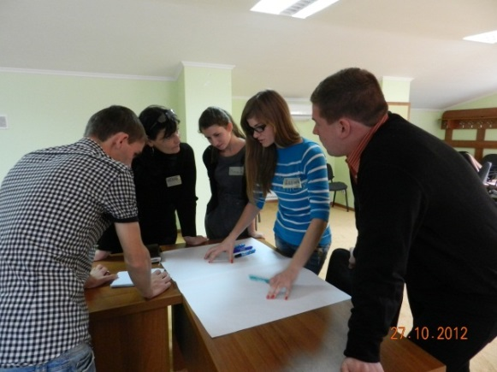**Approved budget:** 24,997.00 USD

**Timeframe:** September 10, 2012-September 9, 2013

**Overall goal of the project:** To build and develop, through empowerment and capacity building activities, 15 civil society and local community groups from both sides of the Nistru river, making them aware of the fundamental human rights, able to claim and uphold them, and to engage these groups in human rights protection activities at the local level.

**Project’s geographic area**: Both banks of the Nistru River, including Gagauz Yeri.

*Community leaders identifying local needs*

**Project status: On-going, delivery-60%.**

**Project results:**

* 27 community leaders from both banks of Nistru River enrolled in a training program. 14 of them are women and 13 men, 16 from the left bank and 11 from the right bank of Nistru River.
* The 27 community leaders coming from grass roots organizations from Transnistrian region, Gagauz Yeri, the Security Zone of the right bank, Bulgarian and Ukrainian regional areas of Moldova have been trained in becoming facilitators for the communities they are coming from by replicating the acquired skills and knowledge, providing to citizens the necessary legal consultations on fundamental human rights, consumer’s rights, patient’s rights, able to claim them effectively and encourage them to participate in local decision-making.
* 27 community leaders have worked on their action plans for the upcoming 4 months (January-April 2013) and set up lists of trainings they needed for increasing their capacities to strengthen the targeted communities. This list will constitute the basis for CIDO for subsequent follow-up trainings to be provided in 2013.

**PRESS clippings:**

<http://www.cido.org.md/index.php?option=com_content&view=article&id=84%3A2012-10-18-20-19-44&catid=9%3Apnado-2011-2014&lang=ro>

<http://www.facebook.com/pages/Centrul-de-Informare-%C3%AEn-domeniul-Drepturilor-Omului-CIDO/184218311611989>

<http://www.undp.md/presscentre/2012/CBM_31October/index.shtml>

### Sub-project 8: „ The democratization of the Transnistrian region through human rights protection”

**Implemented by:** “Center for legal Initiatives”, Tiraspol (“Центр правовых инициатив”) in partnership with the “Lawyers for Human Rights” from Chisinau and Tiraspol University’s Law Department

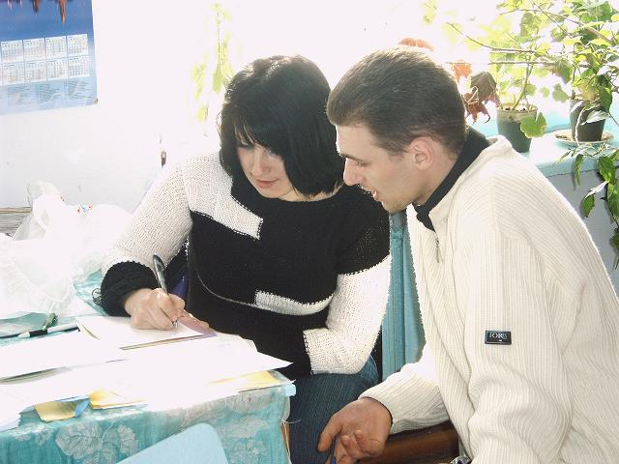

**Project budget:** 25,000.00 USD.

**Project timeframe:** September 12, 2012 – September 11, 2013.

**Beneficiaries:** 300vulnerable people from rural areas of Transnistrian region, community leaders, initiative groups, the local public authorities, women, men and children needing legal support, about 900 school students, pensioners, students at Tiraspol university Law Department, professional lawyers from both banks.

**Project’s geographic area:** Chisinau, Tiraspol, Dubasari, Grigoriopol, Slobozia.

*Regional legal consultation*

**Overall goal of the project:** To provide legal consulting services to vulnerable people living in rural areas of Transnistria Region and provide trainings to schools students from Transnistrian region on fundamental human rights.

**Project status: On-going, delivery-90%.**

**Project results:**

* Regional legal consultations provided to 93 vulnerable people living in rural areas of the left bank; in Blijnii Hutor, Suklea, Ternovka, Slobozea, Popenki and Tiraspol.
* Legal consultations in the following fields: miscalculations of pensions, payment of social allowances, private property division upon divorces, NGOs registration, and labor and civil law related issues.
* 15 training sessions to pupils from Tiraspol, Ternovka, Grigoriopol on basic human rights, legal self-defence, anti-trafficking measures, illegal labour exploitation of children, roads safety, children rights, family law, administrative contraventions, etc.
* Public awareness about the legal consultations free of charge available to vulnerable citizen living on the left bank through printed materials, website announcements <http://www.nr2.ru/pmr/417921.html> posted within the local public authorities from the region.

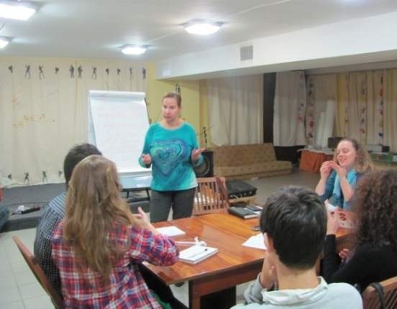

### Sub-project 9: “Half empty or half full”

**Implemented by:** “Apriori” from Tiraspol in partnership with «Step Forward» NGO, from Tiraspol and “Family Planning Association” from Chisinau

**Approved budget:** 25,000.00 USD

**Project timeframe:** September 24, 2012- September 23, 2013

**Beneficiaries:** About 200 single parents, mothers educating young children in difficult circumstances, 15 women journalists, local NGOs providing the same kind of services.

*Journalism for women session*

**Project’s geographic area**: Chisinau, Tiraspol and other regions from the left bank.

**Project status: On-going, delivery-60%.**

**Overall goal of the project:** Promoting human rights and providing social protection to vulnerable families educating their underage children.

**Project results:**

* Under this partnership 10 legal consultations to 19 single parents educating their children on their own have been provided so far. The main issues raised by project beneficiaries were: after divorce issues, social indemnities payment, rights of single mothers, labour related issues, property rights, children and women’s rights protection and empowering.
* Psycho-social support to 15 single parents has been provided within the parent’s school activity and psychologist consultations were open for the public three times per week where the parents are learning from professionals how they can better educate their children.
* Besides this, “Apriori” staff, supported by its volunteers is offering the opportunity to vulnerable mothers from Transnistria region to develop professionally involving them in various training sessions, such as parents’ school, access to information, physicians’ consultations (15 beneficiaries have received medical advice on their diseases).
* Under the journalism school for women, 10 women and 3 men are enrolled and trained on practical journalism rules. Reports on human lives are prepared by beginner journalists and posted on NGO blog: <http://suslikov.net/blog/dva_serdca/>.
* Currently the journalism school is developing an on-line TV show that will be broadcast on Apriori webpage.

**PRESS clippings:**

<http://suslikov.net/blog/dva_serdca/188.html>

<http://www.nr2.ru/pmr/413649.html>

<http://suslikov.net/blog/dva_serdca/192.html>

<http://suslikov.net/blog/dva_serdca/193.html>

### Sub-project 10: „ Promoting foster families services in Transnistrian Region”

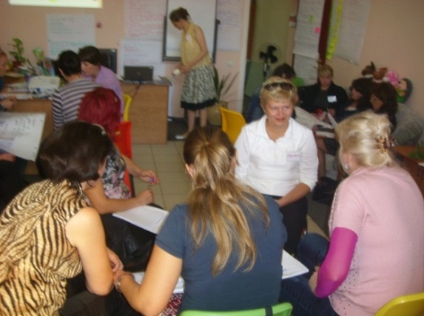

**Implemented by:** „Childhood to Children NGO”, Tiraspol («Детство Детям») in partnership with “Partnerships to Every Child” NGO from Chisinau

**Approved budget: 25,000.00 USD**

**Timeframe:** September 5, 2012-September 4, 2013

**Beneficiaries:** About 20 institutionalized children from Transnistria region to be placed in foster families and 35 foster families’ candidates to be trained, 20 social servants from Tiraspol the administration.

*Social servants exploring the foster services*

**Project’s geographic area:** Chisinau, Tiraspol, Bender and other regions from the left bank of the Nistru.

**Project status: On-going, delivery-60%.**

**Overall goal of the project:** To establish a partnership mechanism with the government officials for professional foster families’ services providing in Transnistrian Region.

**Project results:**

* During September-November 2012, 20 social servants have followed a 3 modules training on social assistance to foster families using methodologies and lessons learned and being coached by Partnerships for Every Child NGO from Chisinau, being adjusted to the local needs and specifics.
* The foster services specifics for Transnistrian region have been discussed and a partnership memorandum has been elaborated together with public servants responsible for child protection, in order to ensure effectiveness and feasibility.
* The jointly elaborated guidelines serve as methodological basis for the project.
* Public awareness campaign about foster families launched using all the possible information means: 200 leaflets have been printed and distributed, the project core staff participated on 3 TV programs, 11 media meetings have been organized focusing about 300 people potential candidates in foster parents.
* Experience and knowledge transferred from the right bank to the left bank and vice versa as a result of NGO partnership

**PRESS clippings:**

<http://www.youtube.com/watch?v=tW0D_wE0En4>

<http://www.undp.md/presscentre/2012/CBM_15October/index.shtml>

<http://eeas.europa.eu/delegations/moldova/press_corner/all_news/news/2012/20121016.pdf>

### Sub-project 11: „ Support to disabled people from Transnistria and Moldova”

**Implemented by:** “The world of Equal opportunities”, Bender (Мир равных возможностей) in partnership with “Invasport” and “Motivația” NGOs from Chisinau and “Miloserdie” NGO from Bender

**Project budget:** 24,987.50 USD

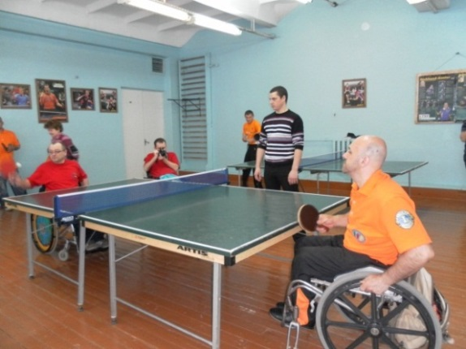

**Timeframe:** September 12, 2012 – September 11, 2013

**Beneficiaries:** 50 physically disabled people from banks and 50 relatives of physically disabled people, at least 25 social and public servants from Transnistria region, 10 representatives from civil society NGOs working in the same field, 15 students from social assistance faculty, school students from Bender, mass-media from both banks.

*Tennis tournament for disabled people*

**Project’s geographic area:** Chisinau, Tiraspol, Bender, Slobozia, Dubasari, etc.

**Project status: On-going, delivery-60%.**

**Overall goal of the project:** To protect the rights of the disabled people living on both banks of the Nistru River and to contribute to improving the conditions of their lives.

**Project results:**

* About 30 physically disabled people from both banks are being supported by creating better conditions and opportunities for socializing, practicing sports, and improving their access to information.
* Public awareness and tolerance is being increased about the existence of disabled people and their needs.
* A resources centre has been equipped and furnished contributing to the disabled people social inclusion, for thematic meetings and trainings organization.
* Within the quipped gym, people in wheelchairs play table tennis and other sports activities 3 times per week.
* Experience and knowledge transferred from the right bank to the left bank and vice versa as a result of NGO partnership

**PRESS clippings:**

<http://www.undp.md/presscentre/2012/CBM_8November/index.shtml>

<https://mail.google.com/mail/ca/?shva=1#search/%D1%81%D0%BF%D0%BE%D1%80%D1%82+%D1%80%D0%B5%D0%B2%D1%8E/13abb077d3d6b3f0>

<http://www.radiopmr.org/news/8707/3/V-Benderax-proshel-respublikanskij-otkrytyj-turnir-po-nastolnomu-tennisu-sredi-parasportsmenov-Kubok-Benderskoj-kreposti/?sphrase_id=4813>

<http://www.nr2.ru/pmr/419758.html>

### Sub-project 12: „ Monitoring the human impact on the Nistru River”

**Implemented by:** “Vitality” NGO, Tiraspol in partnership with “Renașterea Rurală” NGO from Tohatin

**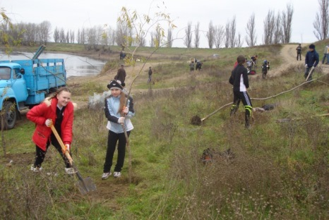**

**Project budget:** 24,975.00 USD

**Project timeframe:** September 5, 2012-September 4, 2013

**Beneficiaries:** 20 teachers of biology, chemistry and geography and 200 school studentsfrom both banks, 10 public servants working in the environmental protection field from both banks, citizen living along Nistru River and local public authorities from both banks.

**Project geographic area:** Chisinau, Tohatin, Vadul lui Voda, Bender, Tiraspol, Parkani, Grigoriopol, etc.

*Greening activities on Nistru valley*

**Overall goal of the project:** To monitor the human impact for the aquatic biodiversity and ecosystems on the lower course of the Nistru river.

**Project status: On-going.**

**Project results:**

* Nistru River ecological situation jointly monitored and practical waste management and greening activities jointly implemented by NGOs from both banks.
* About 1,000 trees and bushes planted on both sides of the river.
* The findings of the monitoring activities of the Nistru ecological situation have been presented to other NGOs working on environmental issues and decision makers on both banks.
* Through distribution of printing materials, Vitality NGO has contributed to public information about the Nistru ecological situation and encouraged the youth from both banks to protect the fauna and flora in the communities they are living.

**PRESS clippings:**

<http://www.nr2.ru/pmr/414835.html>

<http://mediacenter.hostink.ru/iann/278-na-beregu-dnestra-posadili-dvesti-derevev.html>

<http://www.undp.md/presscentre/2012/CBM_30November/index_rom.shtml>

## 5.3.2. Dialogues programme/Civil Society Support to Working Groups

As part of the civil society component, an informal platform for civil society leaders and experts to support Confidence Building Working groups on **Economy/Trade and Social Protection/ Humanitarian Aid** groups is under the process of being established. Following UNDP rules, a thorough procurement process is on-going to select 4 local civil society experts from both banks (21 application have been submitted for this position overall), one team leader (30 application submitted), a facilitator (27 application submitted) and a logistics administrator (18 applications submitted). This team of professionals supported by the SCBM team will be involved in 4 working meetings and 2 study trips in 2013 year. The informal setting and environment under this initiative will enable the groups to identify and focus on non-political, developmental areas and concerns that are of strong interest for both sides, and work out, with the help of civil society, experts and UNDP project team, the modalities of turning them into workable projects that could be realistically implemented on the ground. The ideas generated through these dialogues, which are difficult for Working Groups to promote because of their formal, political settings, will be translated into specific CBM ideas and blueprints for development projects.

# VI. PROJECT RISKS, ISSUES AND ACTIONS TAKEN

Despite an initial acceptance by TN region authorities of the list of pre-selected projects during talks with representatives of the EU Delegation, after the change of leadership in the region, almost each work plan and every project had to be agreed once again with the new region’s administration in the respective field. Due to these circumstances, the launch of some projects was postponed or the implementation of pre-agreed work plans endangered. Some projects required extensive re-negotiation and explanation, and there’s still significant amount of risk that some projects will be turned down, more specifically, the project on the business incubator and the micro-finance facility.

Despite these hurdles, the UNDP team succeeded to launch almost all agreed sub projects and initiatives and is swiftly reacting to all issues by maintaining a permanent dialogue with counterparts in the region. The UNDP team succeeded to establish all project activities firmly on the ground and solve implementation issues in cooperation with project implementers and beneficiaries.

From the operational point of view, UNDP made sure that activities are being implemented in a smooth manner, proper action being taken in advance. The team was recruited during the initiating of the programme process, so that when the agreement was signed, the full team was in place. Additionally, it is worth mentioning some operational changes that took place within the team. The programme manager has departed for an international post in September 2012, thus his position was advertised and a new manager selected in the following months.

**Risk Table**

|  |  |  |
| --- | --- | --- |
| **Description of risk** | **Type and Category** | **Risk management actions during 2010** |
| Changes in regional authorities; volatile political and security environment, subject to unforeseen and sudden changes | Political/ High | The project team analysed, monitored and accounted for the specific political environment in the region. After the changes in the leadership of the region, the project quickly established working relationships with the key actors, emphasizing the non-political, development-focused nature of the Programme and has ensured their buy-in, providing continuity with the previous phases.  The implementation of all projects were planned and approached with caution, and thorough, in-depth consultations were conducted on each activity under all programme areas. The timing, visibility and presentation issues were thoroughly thought through and monitored.  The project team succeeded to prevent political obstacles in the way of several projects and had numerous meetings with representatives of regional authorities to make possible the launching of the projects according to agreed schedules. Concerns were addressed in a development-focused way. |
| Activities may be delayed due to the regional context | Operational / Medium | The project team ensured that the local administration is informed on an on-going basis about the aims and the activities planned, having regular meetings with them and involving them in the activities of the projects. It is important to note the importance of the non-political nature of all planned and therefore implemented activities. |
| Different financial systems in the Transnistrian region | Operational / Medium | The UNDP worked through accounts on the right bank, transferring funds to Moldovan accounts of the implementing partners |
| Low capacity of civil society in the Transnistrian region to implement and absorb the assistance | Operational / High | To avoid this risk, a mixed approach in the implementation of activities is taken. Beside grants programmes, direct support to proposal development, as well as preparation for all technical information (i.e. infrastructure projects) was provided to the implementation partners. Permanent support is provided in terms of performance indicators tracking and actual implementation process. |

# VII. MEDIA COVERAGE

The project team has put together a media approach to promote the projects on both banks. As a result, all of the SCBM projects have been covered extensively by the only two TV channels in Transnistria, TSV and Channel 1. Projects also received extensive coverage in radio outlets, newspapers and web portals on both banks of river Nistru, which enhanced EU’s and UNDP’s visibility in the region and explained to the broader public the goals and purposes of the confidence-building projects in the region.

A multitude of TV reports have been shown on both Transnistrian TV channels about the business school, raising its prestige and demonstrating the practical benefits of EU’s presence in the region. Reports were aired about most other components of the program, including environment, infrastructure and health. .

The communication approach of the project included a series of activities aiming to raise public awareness from two sides of Nistru River on implementation of the SCBM project. The approach is focused on usage of different efficient communication and media tools for promotion of project activities and results such as TV and Radio reportages and interview, newspaper articles etc. The focus is on non-political areas and the relevance of these projects to the needs of the population, as well as SCBM project activities and achievements, ensuring visibility and communication, and promotion of the beneficiaries’ results.

The use of social media was also considerable, with a relatively high impact on the public at large; worth highlighting here the Gallery of successful women, - a campaign dedicated to the International Women day, when during a week, each day the portrait of a woman, beneficiary of the CBM project was presented and project results highlighted.

The objective is to provide timely and consistent information to beneficiaries, media and authorities/partners involved in the project; ensuring maximum transparency of the assistance efforts; identifying and implementing of efficient mechanisms for distribution of the information about the project’s activities and results to the target group of the project; information and rising awareness of public opinion from two sides of the Nistru River about the social-economic problems and necessities in Transnistrian region. During this phase, 4 launch events have been successfully conducted and the media and public opinion were regularly informed, including through 22 Press Releases, 20 TV reportages and programmes, 23 radio news, 15 newspaper articles, 50 info news, as well as through visibility materials.

1. Contract N 2012/284-007, Annex I, Description of the Action, Support to Confidence Building Measures [↑](#footnote-ref-1)
2. Contract N 2012/284-007, Annex I, Description of the Action, Support to Confidence Building Measures [↑](#footnote-ref-2)
3. Independent Evaluation of the UNDP Confidence Building Measures Intervention in Transnistria, 2011 <http://erc.undp.org/evaluationadmin/manageevaluation/viewevaluationdetail.html?evalid=5412> [↑](#footnote-ref-3)